LAMPIRAN

Lampiran 1
Hasil Perhitungan Variabel Transfer Pricing
 |  |  |  | Y
No. | Emiten |  | Tahun | Sales to Related Parties (Rp) | Total Sales  (Rp) | Transfer Pricing
1. | ADRO |  | 2014 | 0 | 46.444.813.626 | 0.00
1. |  |  | 2015 | 64.078.302.000 | 37.492.734.054.000 | 0.00
1. |  |  | 2016 | 27.039.144.000 | 35.254.783.993.500 | 0.00
1. |  |  | 2017 | 14.217.897.000 | 45.507.507.844.500 | 0.00
1. |  |  | 2018 | 59.427.457.500 | 50.555.252.341.500 | 0.00
2. | BSSR |  | 2014 | 1.577.971.971.727 | 3.032.272.443.499 | 0.52
2. |  |  | 2015 | 407.145.164.974 | 3.617.613.262.975 | 0.11
2. |  |  | 2016 | 539.086.439.077 | 3.388.252.439.077 | 0.16
2. |  |  | 2017 | 860.141.651.124 | 5.482.886.642.511 | 0.16
2. |  |  | 2018 | 1.303.109.477.982 | 6.193.198.656.499 | 0.21
3. | DEWA |  | 2014 | 2.848.104.713.598 | 3.277.436.459.913 | 0.87
3. |  |  | 2015 | 3.324.918.314.097 | 3.353.691.468.904 | 0.99
3. |  |  | 2016 | 3.319.620.443.551 | 3.623.063.717.533 | 0.92
3. |  |  | 2017 | 3.048.764.938.656 | 3.390.938.741.721 | 0.90
3. |  |  | 2018 | 3.422.086.243.428 | 3.856.110.133.183 | 0.89
4. | ELSA |  | 2014 | 2.487.680.000.000 | 4.221.172.000.000 | 0.59
4. |  |  | 2015 | 2.217.556.000.000 | 3.775.323.000.000 | 0.59
4. |  |  | 2016 | 2.219.130.000.000 | 36.20.570.000.000 | 0.61
4. |  |  | 2017 | 3.020.742.000.000 | 4.978.986.000.000 | 0.61
4. |  |  | 2018 | 4.458.944.000.000 | 6.624.774.000.000 | 0.67

5. | GEMS | 2014 | 2.230.755.660.907 | 5.185.585.519.326 | 0.43
5. | GEMS | 2015 | 2.151.182.004.783 | 4.932.772.310.899 | 0.44
5. | GEMS | 2016 | 1.661.359.577.883 | 5.367.882.319.494 | 0.31
5. | GEMS | 2017 | 2.291.076.541.692 | 10.606.835.841.169 | 0.22
5. | GEMS | 2018 | 3.918.974.921.557 | 14.595.809.763.714 | 0.27
6. | ITMG | 2014 | 1.924.569.733.500 | 27.132.091.057.500 | 0.07
6. | ITMG | 2015 | 2.304.402.667.500 | 22.198.480.798.500 | 0.10
6. | ITMG | 2016 | 1.304.038.138.500 | 19.099.160.817.000 | 0.07
6. | ITMG | 2017 | 1.905.421.662.000 | 23.596.750.912.500 | 0.08
6. | ITMG | 2018 | 961.803.022.500 | 28.039.564.395.000 | 0.03
7. | MBAP | 2014 | 1.735.711.941.166 | 1.799.139.208.735 | 0.96
7. | MBAP | 2015 | 1.377.385.797.052 | 3.060.250.206.132 | 0.45
7. | MBAP | 2016 | 363.411.472.462 | 2.613.911.760.030 | 0.14
7. | MBAP | 2017 | 940.963.482.151 | 3.611.542.723.750 | 0.26
7. | MBAP | 2018 | 904.142.927.809 | 3.605.284.782.028 | 0.25
8. | PTBA | 2014 | 5.909.717.000.000 | 13.077.962.000.000 | 0.45
8. | PTBA | 2015 | 6.264.641.000.000 | 13.845.199.000.000 | 0.45
8. | PTBA | 2016 | 6.980.190.000.000 | 14.058.869.000.000 | 0.50
8. | PTBA | 2017 | 9.968.173.000.000 | 19.471.030.000.000 | 0.51
8. | PTBA | 2018 | 9.827.865.000.000 | 21.166.993.000.000 | 0.46

Lampiran 2
Hasil Perhitungan Variabel Independen
No | Emiten | Tahun | Tax | Bonus | DC | KA | Size | MULTI
1. | ADRO | 2014 | 0.43 | 0.79 | 0.97 | 0.25 | 32.13 | 0.13
 | ADRO | 2015 | 0.46 | 0.82 | 0.44 | 0.25 | 32.05 | 0.12
 | ADRO | 2016 | 0.38 | 2.26 | 0.72 | 0.25 | 32.14 | 0.09
 | ADRO | 2017 | 0.42 | 1.57 | 0.40 | 0.27 | 32.19 | 0.08
 | ADRO | 2018 | 0.42 | 0.89 | 0.39 | 0.22 | 25.31 | 0.08
2. | BSSR | 2014 | 0.51 | 0.54 | 0.86 | 0.26 | 28.48 | 0.00
 | BSSR | 2015 | 0.28 | 10.36 | 0.40 | 0.26 | 28.52 | 0.00
 | BSSR | 2016 | 0.23 | 1.04 | 0.44 | 0.31 | 28.57 | 0.00
 | BSSR | 2017 | 0.26 | 3.02 | 0.29 | 0.41 | 28.71 | 0.00
 | BSSR | 2018 | 0.26 | 0.83 | 0.63 | 0.40 | 28.86 | 0.00
3. | DEWA | 2014 | 0.95 | 0.01 | 0.60 | 0.41 | 29.23 | 0.50
 | DEWA | 2015 | 0.91 | 1.56 | 0.66 | 0.40 | 29.28 | 0.25
 | DEWA | 2016 | 0.80 | 1.18 | 0.69 | 0.37 | 29.30 | 0.14
 | DEWA | 2017 | 0.74 | 5.04 | 0.77 | 0.32 | 29.36 | 0.14
 | DEWA | 2018 | 0.62 | 0.93 | 0.80 | 0.31 | 29.39 | 0.14
4. | ELSA | 2014 | 0.25 | 1.72 | 0.64 | 0.14 | 29.08 | 0.00
 | ELSA | 2015 | 0.26 | 0.88 | 0.67 | 0.10 | 29.11 | 0.00
 | ELSA | 2016 | 0.26 | 0.83 | 0.46 | 0.11 | 29.06 | 0.00
 | ELSA | 2017 | 0.26 | 0.79 | 0.59 | 0.12 | 29.21 | 0.00
 | ELSA | 2018 | 0.27 | 1.10 | 0.71 | 0.15 | 29.36 | 0.00
5. | GEMS | 2014 | 0.08 | 0.59 | 0.27 | 0.30 | 29.11 | 0.09
 | GEMS | 2015 | 0.26 | 0.19 | 0.49 | 0.97 | 29.27 | 0.15
 | GEMS | 2016 | 0.29 | 16.75 | 0.43 | 0.99 | 29.29 | 0.13
 |  | 2017 | 0.28 | 3.43 | 1.02 | 0.99 | 29.74 | 0.11
 |  | 2018 | 0.26 | 0.84 | 1.22 | 0.97 | 29.91 | 0.09
6. | ITMG | 2014 | 0.28 | 0.98 | 0.45 | 0.90 | 30.54 | 0.00
 | ITMG | 2015 | 0.55 | 0.31 | 0.41 | 0.80 | 30.37 | 0.00
 | ITMG | 2016 | 0.32 | 2.07 | 0.33 | 0.88 | 30.46 | 0.00
 | ITMG | 2017 | 0.30 | 1.93 | 0.42 | 0.87 | 30.57 | 0.00
 | ITMG | 2018 | 0.30 | 1.02 | 0.49 | 0.86 | 30.63 | 0.00
7. | MBAP | 2014 | 0.28 | 3.62 | 0.74 | 0.33 | 27.75 | 0.00
 | MBAP | 2015 | 0.27 | 2.49 | 0.48 | 0.30 | 28.05 | 0.00
 | MBAP | 2016 | 0.25 | 0.78 | 0.27 | 0.30 | 28.12 | 0.00
 | MBAP | 2017 | 0.26 | 2.16 | 0.31 | 0.34 | 28.44 | 0.00
 | MBAP | 2018 | 0.26 | 0.86 | 0.28 | 0.34 | 28.52 | 0.00
8. | PTBA | 2014 | 0.25 | 1.09 | 0.71 | 0.45 | 30.33 | 0.06
 | PTBA | 2015 | 0.26 | 1.09 | 0.82 | 0.11 | 30.46 | 0.04
 | PTBA | 2016 | 0.26 | 0.99 | 0.76 | 0.08 | 30.55 | 0.04
 | PTBA | 2017 | 0.25 | 2.25 | 0.59 | 0.10 | 30.72 | 0.04
 | PTBA | 2018 | 0.25 | 1.13 | 0.49 | 0.18 | 30.82 | 0.04

Lampiran 3
Hasil Olah Data Menggunakan software Statistical Package for Social Science (SPSS) Versi 25
Uji Statistik Deskriptif
Descriptive Statistics
 | N | Minimum | Maximum | Mean | Std. Deviation
TP | 40 | .00 | .99 | .3813 | .30643
TAX | 40 | .08 | .95 | .3602 | .19446
BONUS | 40 | -.01 | 16.75 | 2.0178 | 2.95351
DC | 40 | .27 | 1.22 | .5778 | .22099
FO | 40 | .08 | .99 | .4093 | .29296
SIZE | 40 | 25.31 | 32.19 | 29.5748 | 1.34383
MULTI | 40 | .00 | .50 | .0615 | .09472
Valid N (listwise) | 40

Uji Normalitas
One-Sample Kolmogorov-Smirnov Test
 |  | Unstandardized Residual
N |  | 40
Normal Parameters^{a,b} | Mean | .0000000
Normal Parameters^{a,b} | Std. Deviation | .22284408
Most Extreme Differences | Absolute | .105
Most Extreme Differences | Positive | .105
Most Extreme Differences | Negative | -.091
Test Statistic |  | .105
Asymp. Sig. (2-tailed) |  | .200^{c,d}
a. Test distribution is Normal.
b. Calculated from data.
c. Lilliefors Significance Correction.
d. This is a lower bound of the true significance.

Uji Multikolinearitas
Model |  | Collinearity Statistics
 |  | Tolerance | VIF
1 | (Constant)
1 | TAX | .452 | 2.211
1 | BONUS | .911 | 1.097
1 | DC | .897 | 1.114
1 | FO | .909 | 1.100
1 | SIZE | .922 | 1.085
1 | MULTI | .443 | 2.258

Uji Autokorelasi
Model Summary^{b}
Model | R | R Square | Adjusted R Square | Std. Error of the Estimate | Durbin-Watson
1 | .686ª | .471 | .375 | .24226 | .772
a. Predictors: (Constant), MULTI, BONUS, SIZE, FO, DC, TAX
b. Dependent Variable: TP

Uji Heteroskedastisitas
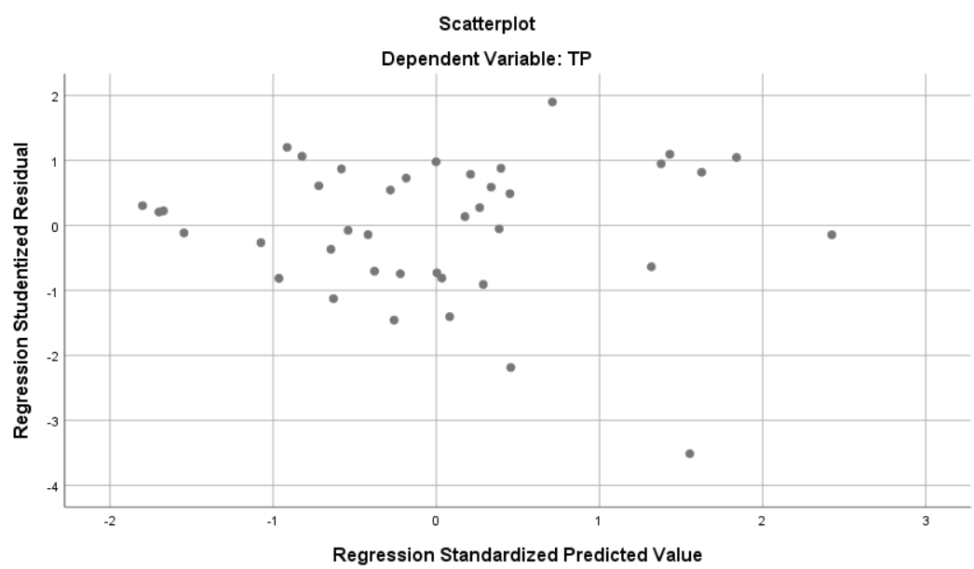
Uji Parsial (Uji T)
Model |  | Unstandardized Coefficients |  | Standardized Coefficients | t | Sig.
 |  | B | Std. Error | Beta | t | Sig.
1 | (Constant) | 2.301 | .880 |  | 2.614 | .013
1 | TAX | .401 | .297 | .254 | 1.351 | .186
1 | BONUS | .005 | .014 | .044 | .330 | .744
1 | DC | .455 | .185 | .328 | 2.455 | .020
1 | FO | -.315 | .139 | -.301 | -2.271 | .030
1 | SIZE | -.076 | .030 | -.332 | -2.521 | .017
1 | MULTI | .562 | .615 | .174 | .914 | .367
- Dependent variable: TP
Uji Koefisien Determinasi (R²)
Model | R | R Square | Adjusted R Square | Std. Error of the Estimate
1 | .686ª | .471 | .375 | .24226
- Predictors: (Constant), MULTI, BONUS, SIZE, FO, DC, TAX
- Dependent Variable: TP
Uji F
ANOVAª
Model |  | Sum of Squares | df | Mean Square | F | Sig.
1 | Regression | 1.725 | 6 | .288 | 4.900 | .001^{b}
1 | Residual | 1.937 | 33 | .059
1 | Total | 3.662 | 39
a. Dependent Variable: TP
b. Predictors: (Constant), MULTI, BONUS, SIZE, FO, DC, TAX

