REGRESSION
/DESCRIPTIVES MEAN STDDEV CORR SIG N
/MISSING LISTWISE
/STATISTICS COEFF OUTS R ANOVA COLLIN TOL
/CRITERIA=PIN(.05) POUT(.10)
/NOORIGIN
/DEPENDENT Y
/METHOD=ENTER X1 X2 X3 X4
/SCATTERPLOT=(*SRESID ,*ZPRED)
/RESIDUALS DURBIN HISTOGRAM(ZRESID) NORMPROB(ZRESID)
/SAVE RESID.

Regression

Notes
Output Created |  | 16-FEB-2021 14:56:15
Comments
Input | Active Dataset | DataSet0
Input | Filter | <none>
Input | Weight | <none>
Input | Split File | <none>
Input | N of Rows in Working Data File | 60
Missing Value Handling | Definition of Missing | User-defined missing values are treated as missing.
Missing Value Handling | Cases Used | Statistics are based on cases with no missing values for any variable used.
Syntax |  | REGRESSION  /DESCRIPTIVES MEAN STDDEV CORR SIG N  /MISSING LISTWISE  /STATISTICS COEFF OUTS R ANOVA COLLIN TOL  /CRITERIA=PIN(.05) POUT(.10)  /NOORIGIN  /DEPENDENT Y  /METHOD=ENTER X1 X2 X3 X4  /SCATTERPLOT=(*SRESID ,*ZPRED)  /RESIDUALS DURBIN HISTOGRAM(ZRESID) NORMPROB(ZRESID)  /SAVE RESID.
Resources | Processor Time | 00:00:03.28
Resources | Elapsed Time | 00:00:03.56
Resources | Memory Required | 2308 bytes
Resources | Additional Memory Required for Residual Plots | 888 bytes
Variables Created or Modified | RES_1 | Unstandardized Residual

[DataSet0]

Descriptive Statistics
 | Mean | Std. Deviation | N
Harga Saham | 3414.5500 | 3915.72517 | 60
EPS | 1325.0398 | 5485.53169 | 60
NPM | 10.2058 | 10.43136 | 60
ROA | 10.4525 | 10.40603 | 60
ROE | 21.4210 | 28.96925 | 60

Correlations
 |  | Harga Saham | EPS | NPM | ROA | ROE
Pearson Correlation | Harga Saham | 1.000 | .349 | .683 | .728 | .728
Pearson Correlation | EPS | .349 | 1.000 | .371 | .420 | .533
Pearson Correlation | NPM | .683 | .371 | 1.000 | .862 | .689
Pearson Correlation | ROA | .728 | .420 | .862 | 1.000 | .911
Pearson Correlation | ROE | .728 | .533 | .689 | .911 | 1.000
Sig. (1-tailed) | Harga Saham | . | .003 | .000 | .000 | .000
Sig. (1-tailed) | EPS | .003 | . | .002 | .000 | .000
Sig. (1-tailed) | NPM | .000 | .002 | . | .000 | .000
Sig. (1-tailed) | ROA | .000 | .000 | .000 | . | .000
Sig. (1-tailed) | ROE | .000 | .000 | .000 | .000 | .
N | Harga Saham | 60 | 60 | 60 | 60 | 60
N | EPS | 60 | 60 | 60 | 60 | 60
N | NPM | 60 | 60 | 60 | 60 | 60
N | ROA | 60 | 60 | 60 | 60 | 60
N | ROE | 60 | 60 | 60 | 60 | 60

Variables Entered/Removedª
Model | Variables Entered | Variables Removed | Method
1 | ROE, EPS, NPM, ROA^{b} | . | Enter
a. Dependent Variable: Harga Saham
b. All requested variables entered.

Model Summary^{b}
Model | R | R Square | Adjusted R Square | Std. Error of the Estimate | Durbin-Watson
1 | .776ª | .603 | .574 | 2556.07497 | .473
a. Predictors: (Constant), ROE, EPS, NPM, ROA
b. Dependent Variable: Harga Saham

ANOVAª
Model |  | Sum of Squares | df | Mean Square | F | Sig.
1 | Regression | 545297751.090 | 4 | 136324437.773 | 20.865 | .000^{b}
1 | Residual | 359343559.760 | 55 | 6533519.268
1 | Total | 904641310.850 | 59
a. Dependent Variable: Harga Saham
b. Predictors: (Constant), ROE, EPS, NPM, ROA

Coefficientsª
Model |  | Unstandardized Coefficients |  | Standardized Coefficients | t | Sig. | Collinearity Statistics
 |  | B | Std. Error | Beta | t | Sig. | Tolerance | VIF
1 | (Constant) | 780.154 | 490.886 |  | 1.589 | .118
1 | EPS | -.064 | .075 | -.089 | -.842 | .404 | .646 | 1.548
1 | NPM | 188.170 | 73.600 | .501 | 2.557 | .013 | .188 | 5.323
1 | ROA | -130.403 | 132.100 | -.347 | -.987 | .328 | .059 | 17.064
1 | ROE | 100.891 | 35.525 | .746 | 2.840 | .006 | .105 | 9.564
a. Dependent Variable: Harga Saham

Collinearity Diagnosticsª
Model | Dimension | Eigenvalue | Condition Index | Variance Proportions
 |  |  |  | (Constant) | EPS | NPM | ROA | ROE
1 | 1 | 3.635 | 1.000 | .02 | .02 | .01 | .00 | .00
1 | 2 | .812 | 2.116 | .12 | .55 | .00 | .00 | .00
1 | 3 | .371 | 3.130 | .71 | .25 | .01 | .01 | .02
1 | 4 | .163 | 4.717 | .08 | .05 | .33 | .00 | .16
1 | 5 | .019 | 13.944 | .06 | .14 | .65 | .99 | .81
a. Dependent Variable: Harga Saham

Residuals Statisticsª
 | Minimum | Maximum | Mean | Std. Deviation | N
Predicted Value | 1055.2881 | 13736.2090 | 3414.5500 | 3040.12085 | 60
Std. Predicted Value | -.776 | 3.395 | .000 | 1.000 | 60
Standard Error of Predicted Value | 354.908 | 2400.519 | 612.509 | 414.924 | 60
Adjusted Predicted Value | 1063.2676 | 22744.3652 | 3569.4923 | 3715.31947 | 60
Residual | -2844.83862 | 7154.59717 | .00000 | 2467.90778 | 60
Std. Residual | -1.113 | 2.799 | .000 | .966 | 60
Stud. Residual | -1.451 | 2.828 | -.016 | 1.012 | 60
Deleted Residual | -10794.36523 | 7304.69189 | -154.94234 | 2990.20002 | 60
Stud. Deleted Residual | -1.466 | 3.032 | -.003 | 1.038 | 60
Mahal. Distance | .154 | 51.054 | 3.933 | 8.500 | 60
Cook's Distance | .000 | 3.146 | .068 | .406 | 60
Centered Leverage Value | .003 | .865 | .067 | .144 | 60
a. Dependent Variable: Harga Saham

Charts

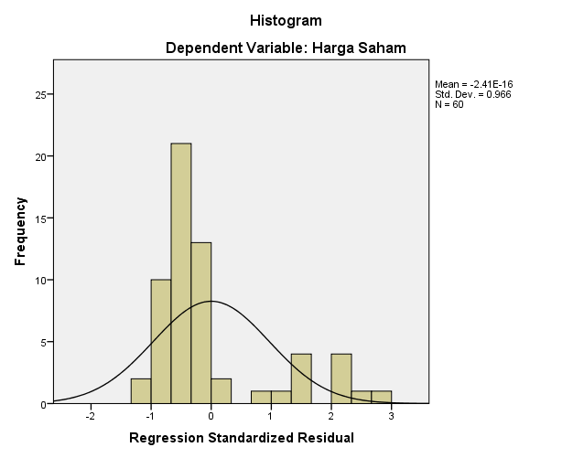

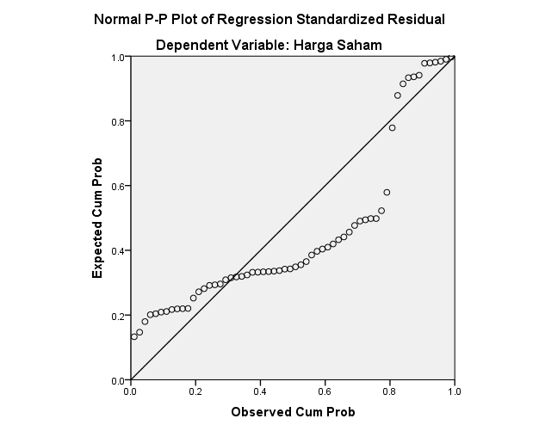

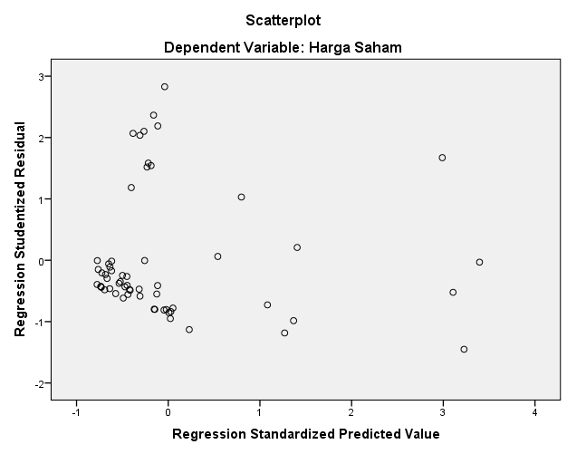

NPAR TESTS
/K-S(NORMAL)=RES_1
/MISSING ANALYSIS.

NPar Tests

Notes
Output Created |  | 16-FEB-2021 14:56:32
Comments
Input | Active Dataset | DataSet0
Input | Filter | <none>
Input | Weight | <none>
Input | Split File | <none>
Input | N of Rows in Working Data File | 60
Missing Value Handling | Definition of Missing | User-defined missing values are treated as missing.
Missing Value Handling | Cases Used | Statistics for each test are based on all cases with valid data for the variable(s) used in that test.
Syntax |  | NPAR TESTS  /K-S(NORMAL)=RES_1  /MISSING ANALYSIS.
Resources | Processor Time | 00:00:00.02
Resources | Elapsed Time | 00:00:00.02
Resources | Number of Cases Allowedª | 196608
a. Based on availability of workspace memory.

[DataSet0]

One-Sample Kolmogorov-Smirnov Test
 |  | Unstandardized Residual
N |  | 60
Normal Parameters^{a,b} | Mean | 0E-7
Normal Parameters^{a,b} | Std. Deviation | 2467.90777978
Most Extreme Differences | Absolute | .269
Most Extreme Differences | Positive | .269
Most Extreme Differences | Negative | -.143
Kolmogorov-Smirnov Z |  | 2.080
Asymp. Sig. (2-tailed) |  | .000
a. Test distribution is Normal.
b. Calculated from data.

GRAPH
/HISTOGRAM(NORMAL)=X1.

Graph

Notes
Output Created |  | 16-FEB-2021 15:06:23
Comments
Input | Active Dataset | DataSet0
Input | Filter | <none>
Input | Weight | <none>
Input | Split File | <none>
Input | N of Rows in Working Data File | 60
Syntax |  | GRAPH  /HISTOGRAM(NORMAL)=X1.
Resources | Processor Time | 00:00:00.58
Resources | Elapsed Time | 00:00:01.67

[DataSet0]

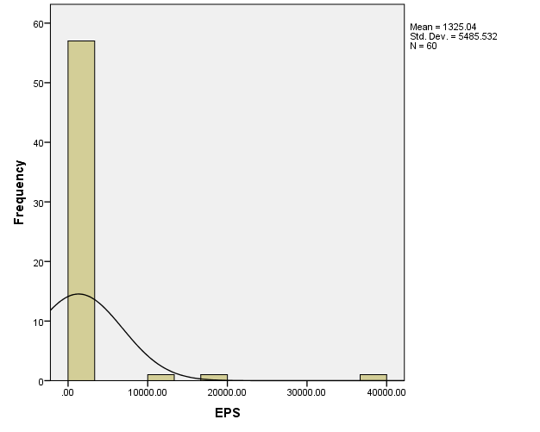

COMPUTE TRANSFORM_X1=SQRT(X1).
EXECUTE.
COMPUTE TRANSFORM_X2=SQRT(X2).
EXECUTE.
COMPUTE TRANSFORM_X3=SQRT(X3).
EXECUTE.
COMPUTE TRANSFORM_X4=SQRT(X4).
EXECUTE.
COMPUTE TRANSFORM_Y=SQRT(Y).
EXECUTE.
REGRESSION
/DESCRIPTIVES MEAN STDDEV CORR SIG N
/MISSING LISTWISE
/STATISTICS COEFF OUTS R ANOVA COLLIN TOL
/CRITERIA=PIN(.05) POUT(.10)
/NOORIGIN
/DEPENDENT TRANSFORM_Y
/METHOD=ENTER TRANSFORM_X1 TRANSFORM_X2 TRANSFORM_X3 TRANSFORM_X4
/SCATTERPLOT=(*SRESID ,*ZPRED)
/RESIDUALS DURBIN HISTOGRAM(ZRESID) NORMPROB(ZRESID)
/SAVE RESID.

DATA SUDAH DI TRANSFORM. SELAMAT MENGANALISIS!!!

Regression

Notes
Output Created |  | 16-FEB-2021 15:14:05
Comments
Input | Active Dataset | DataSet0
Input | Filter | <none>
Input | Weight | <none>
Input | Split File | <none>
Input | N of Rows in Working Data File | 60
Missing Value Handling | Definition of Missing | User-defined missing values are treated as missing.
Missing Value Handling | Cases Used | Statistics are based on cases with no missing values for any variable used.
Syntax |  | REGRESSION  /DESCRIPTIVES MEAN STDDEV CORR SIG N  /MISSING LISTWISE  /STATISTICS COEFF OUTS R ANOVA COLLIN TOL  /CRITERIA=PIN(.05) POUT(.10)  /NOORIGIN  /DEPENDENT TRANSFORM_Y  /METHOD=ENTER TRANSFORM_X1 TRANSFORM_X2 TRANSFORM_X3 TRANSFORM_X4  /SCATTERPLOT=(*SRESID ,*ZPRED)  /RESIDUALS DURBIN HISTOGRAM(ZRESID) NORMPROB(ZRESID)  /SAVE RESID.
Resources | Processor Time | 00:00:00.92
Resources | Elapsed Time | 00:00:01.04
Resources | Memory Required | 2404 bytes
Resources | Additional Memory Required for Residual Plots | 888 bytes
Variables Created or Modified | RES_1 | Unstandardized Residual

[DataSet0]

Descriptive Statistics
 | Mean | Std. Deviation | N
TRANSFORM_Y | 49.6374 | 31.09327 | 60
TRANSFORM_X1 | 19.0840 | 31.25899 | 60
TRANSFORM_X2 | 2.8489 | 1.45775 | 60
TRANSFORM_X3 | 2.9175 | 1.40492 | 60
TRANSFORM_X4 | 4.0541 | 2.25169 | 60

Correlations
 |  | TRANSFORM_Y | TRANSFORM_X1 | TRANSFORM_X2 | TRANSFORM_X3 | TRANSFORM_X4
Pearson Correlation | TRANSFORM_Y | 1.000 | .452 | .739 | .717 | .705
Pearson Correlation | TRANSFORM_X1 | .452 | 1.000 | .476 | .499 | .528
Pearson Correlation | TRANSFORM_X2 | .739 | .476 | 1.000 | .895 | .768
Pearson Correlation | TRANSFORM_X3 | .717 | .499 | .895 | 1.000 | .932
Pearson Correlation | TRANSFORM_X4 | .705 | .528 | .768 | .932 | 1.000
Sig. (1-tailed) | TRANSFORM_Y | . | .000 | .000 | .000 | .000
Sig. (1-tailed) | TRANSFORM_X1 | .000 | . | .000 | .000 | .000
Sig. (1-tailed) | TRANSFORM_X2 | .000 | .000 | . | .000 | .000
Sig. (1-tailed) | TRANSFORM_X3 | .000 | .000 | .000 | . | .000
Sig. (1-tailed) | TRANSFORM_X4 | .000 | .000 | .000 | .000 | .
N | TRANSFORM_Y | 60 | 60 | 60 | 60 | 60
N | TRANSFORM_X1 | 60 | 60 | 60 | 60 | 60
N | TRANSFORM_X2 | 60 | 60 | 60 | 60 | 60
N | TRANSFORM_X3 | 60 | 60 | 60 | 60 | 60
N | TRANSFORM_X4 | 60 | 60 | 60 | 60 | 60

Variables Entered/Removedª
Model | Variables Entered | Variables Removed | Method
1 | TRANSFORM_X4, TRANSFORM_X1, TRANSFORM_X2, TRANSFORM_X3^{b} | . | Enter
a. Dependent Variable: TRANSFORM_Y
b. All requested variables entered.

Model Summary^{b}
Model | R | R Square | Adjusted R Square | Std. Error of the Estimate | Durbin-Watson
1 | .778ª | .606 | .577 | 20.22302 | .484
a. Predictors: (Constant), TRANSFORM_X4, TRANSFORM_X1, TRANSFORM_X2, TRANSFORM_X3
b. Dependent Variable: TRANSFORM_Y

ANOVAª
Model |  | Sum of Squares | df | Mean Square | F | Sig.
1 | Regression | 34547.319 | 4 | 8636.830 | 21.118 | .000^{b}
1 | Residual | 22493.388 | 55 | 408.971
1 | Total | 57040.707 | 59
a. Dependent Variable: TRANSFORM_Y
b. Predictors: (Constant), TRANSFORM_X4, TRANSFORM_X1, TRANSFORM_X2, TRANSFORM_X3

Coefficientsª
Model |  | Unstandardized Coefficients |  | Standardized Coefficients | t | Sig. | Collinearity Statistics
 |  | B | Std. Error | Beta | t | Sig. | Tolerance | VIF
1 | (Constant) | 4.433 | 6.250 |  | .709 | .481
1 | TRANSFORM_X1 | .050 | .101 | .050 | .493 | .624 | .698 | 1.432
1 | TRANSFORM_X2 | 14.351 | 4.490 | .673 | 3.196 | .002 | .162 | 6.181
1 | TRANSFORM_X3 | -10.118 | 8.149 | -.457 | -1.242 | .220 | .053 | 18.907
1 | TRANSFORM_X4 | 8.113 | 3.639 | .588 | 2.230 | .030 | .103 | 9.685
a. Dependent Variable: TRANSFORM_Y

Collinearity Diagnosticsª
Model | Dimension | Eigenvalue | Condition Index | Variance Proportions
 |  |  |  | (Constant) | TRANSFORM_X1 | TRANSFORM_X2 | TRANSFORM_X3 | TRANSFORM_X4
1 | 1 | 4.274 | 1.000 | .01 | .02 | .00 | .00 | .00
1 | 2 | .539 | 2.815 | .04 | .78 | .00 | .00 | .00
1 | 3 | .129 | 5.750 | .90 | .18 | .02 | .01 | .03
1 | 4 | .050 | 9.225 | .02 | .00 | .38 | .00 | .20
1 | 5 | .007 | 25.456 | .03 | .03 | .60 | .99 | .77
a. Dependent Variable: TRANSFORM_Y

Residuals Statisticsª
 | Minimum | Maximum | Mean | Std. Deviation | N
Predicted Value | 20.8203 | 124.9022 | 49.6374 | 24.19809 | 60
Std. Predicted Value | -1.191 | 3.110 | .000 | 1.000 | 60
Standard Error of Predicted Value | 2.783 | 17.205 | 5.177 | 2.721 | 60
Adjusted Predicted Value | 20.1081 | 165.7447 | 50.4807 | 26.72625 | 60
Residual | -26.55483 | 47.23363 | .00000 | 19.52547 | 60
Std. Residual | -1.313 | 2.336 | .000 | .966 | 60
Stud. Residual | -1.466 | 2.366 | -.015 | 1.002 | 60
Deleted Residual | -56.42866 | 48.47731 | -.84334 | 21.65849 | 60
Stud. Deleted Residual | -1.482 | 2.474 | -.006 | 1.020 | 60
Mahal. Distance | .134 | 41.720 | 3.933 | 6.621 | 60
Cook's Distance | .000 | 1.127 | .029 | .145 | 60
Centered Leverage Value | .002 | .707 | .067 | .112 | 60
a. Dependent Variable: TRANSFORM_Y

Charts

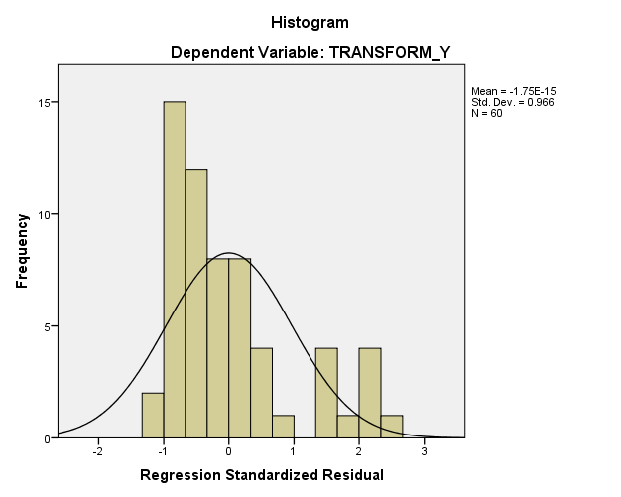

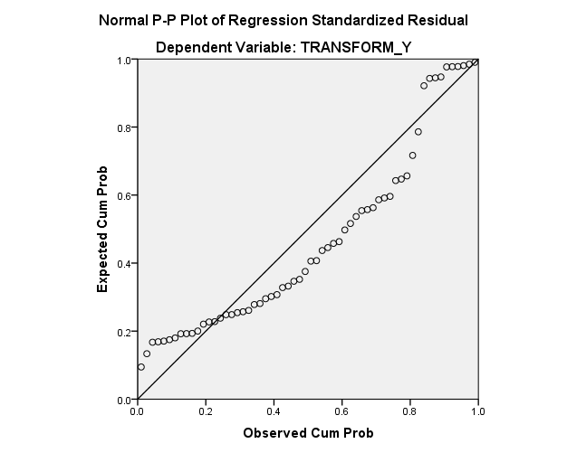

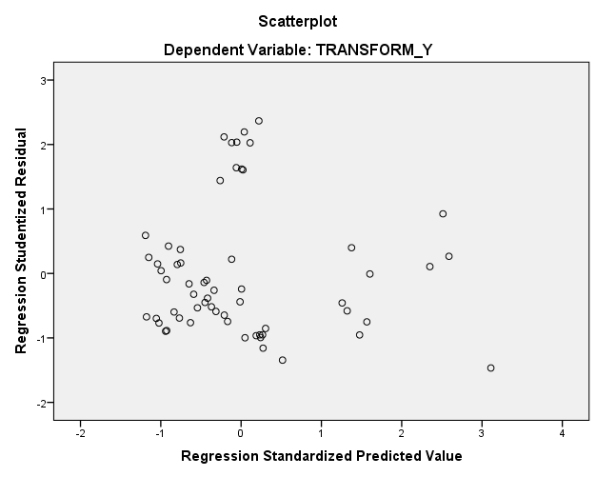

NPAR TESTS
/K-S(NORMAL)=RES_1
/MISSING ANALYSIS.

NPar Tests

Notes
Output Created |  | 16-FEB-2021 15:14:24
Comments
Input | Active Dataset | DataSet0
Input | Filter | <none>
Input | Weight | <none>
Input | Split File | <none>
Input | N of Rows in Working Data File | 60
Missing Value Handling | Definition of Missing | User-defined missing values are treated as missing.
Missing Value Handling | Cases Used | Statistics for each test are based on all cases with valid data for the variable(s) used in that test.
Syntax |  | NPAR TESTS  /K-S(NORMAL)=RES_1  /MISSING ANALYSIS.
Resources | Processor Time | 00:00:00.00
Resources | Elapsed Time | 00:00:00.02
Resources | Number of Cases Allowedª | 196608
a. Based on availability of workspace memory.

[DataSet0]

One-Sample Kolmogorov-Smirnov Test
 |  | Unstandardized Residual
N |  | 60
Normal Parameters^{a,b} | Mean | 0E-7
Normal Parameters^{a,b} | Std. Deviation | 19.52546686
Most Extreme Differences | Absolute | .150
Most Extreme Differences | Positive | .150
Most Extreme Differences | Negative | -.125
Kolmogorov-Smirnov Z |  | 1.165
Asymp. Sig. (2-tailed) |  | .132
a. Test distribution is Normal.
b. Calculated from data.

