Declaration of Originality and Agreement

I/We hereby certify that my/our manuscript titled

Optimasi dan Modifikasi Metode Stomatal Printing pada Pengamatan Stomata Tanaman Kacang Panjang (Vigna sesquipedalis L. Fruwith)

Optimization and Modification of Stomatal Printing Method in Stomata Observation of Long Bean Plant (Vigna sesquipedalis L. Fruwith)

- Is an original work of my/our own, except where indicated by referencing, and does not involve plagiarism.
- This manuscript has not been previously published nor simultaneously submitted to any other publication.
- By this letter, I/we herewith assign copyright to Jurnal Pertanian Presisi (Journal of Precision Agriculture).
- I/we will professionally wait and comply with the review process, and not for any reason withdraw the article before final decision, only if it is rejected. If it is accepted for publication, I must not withdraw it, I/We will follow JPP’s decision, policy and publication schedule. Otherwise, I/we could be sued, and would accept any sanction, including being banned forever from the JIEB submission.

Please write full names of all authors, however, one signature is sufficient to represent all the authors.
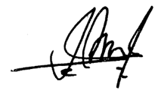

Shalati Febjislami
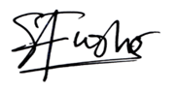
Author [please print full name] Signature May 24, 2023
Date

Sanna Paija Hasibuan
Author [please print full name] Signature May 24, 2023
Date

Author [please print full name] Signature Date

Author [please print full name] Signature
Date

