DECLARATION FORM

PROPOSED TITLE OF MANUSCRIPT :
Depression, Anxiety and Stress Associated With Work Motivation of Indonesian Bank Employees in the New Normal During the COVID-19 Era
AUTHORS (COMPLETE LIST OF AUTHORS) :
Eko Sujadi, Yuserizal Bustami, Muhammad Fadhli

JOURNAL NAME :
Jurnal Psikologi

- I confirm that I have read, understand and agreed to the submission guidelines, policies and submission declaration of the journal.
- I confirm that all authors of the manuscript have no conflict of interests to declare.
- I confirm that the manuscript is the authors' original work and the manuscript has not received prior publication and is not under consideration for publication elsewhere.
- On behalf of all Co-Authors, I shall bear full responsibility for the submission.
- I confirm that all authors listed on the title page have contributed significantly to the work, have read the manuscript, attest to the validity and legitimacy of the data and its interpretation, and agree to its submission.
- I confirm that the paper now submitted is not copied or plagiarized version of some other published work.
- I declare that I shall not submit the paper for publication in any other Journal or Magazine till the decision is made by journal editors.
- If the paper is finally accepted by the journal for publication, I confirm that I will either publish the paper immediately
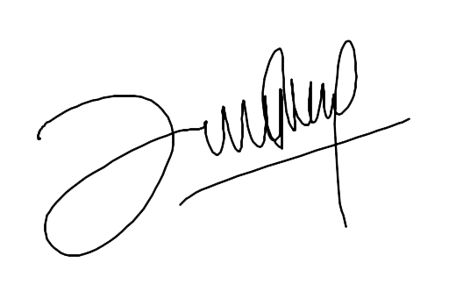

Eko Sujadi Date: 23/07/2022
Signature of Corresponding Author (Signed on behalf of all authors)

