ANALISIS DATA
- Reliabilitas Alat ukur
Reliabilitas dan Total Korelasi Aitem Instrumen Harapan akademik Scale
Frequentist Scale Reliability Statistics
Estimate |  | Cronbach's α
Point estimate |  | 0.834
95% CI lower bound |  | 0.796
95% CI upper bound |  | 0.866

Frequentist Individual Item Reliability Statistics
Item |  | Item-rest correlation
A1 |  | 0.546
A2 |  | 0.637
A3 |  | 0.500
A4 |  | 0.560
A5 |  | 0.547
A6 |  | 0.476
A7 |  | 0.616
A8 |  | 0.541
A9 |  | 0.510

Reliabilitas dan Total Korelasi Aitem Instrumen Grit akademik Scale
Frequentist Scale Reliability Statistics
Estimate |  | Cronbach's α
Point estimate |  | 0.895
95% CI lower bound |  | 0.871
95% CI upper bound |  | 0.915

Frequentist Individual Item Reliability Statistics
Item |  | Item-rest correlation
B1 |  | 0.671
B2 |  | 0.602
B3 |  | 0.671
B4 |  | 0.587
B5 |  | 0.666
B6 |  | 0.648
B7 |  | 0.583
B8 |  | 0.726
B9 |  | 0.685
B10 |  | 0.651

- Uji Asumsi
Tabel Grafik Residual vs Predicted Untuk Uji Hosmokedasitas

Residuals vs. Predicted
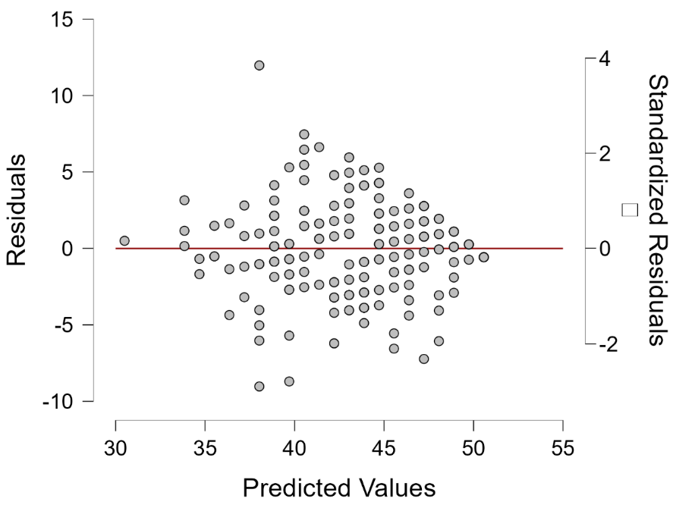

Tabel Q-Q Plot Untuk Uji Normalitas dan Uji Linearitas

Q-Q Plot Standardized Residuals
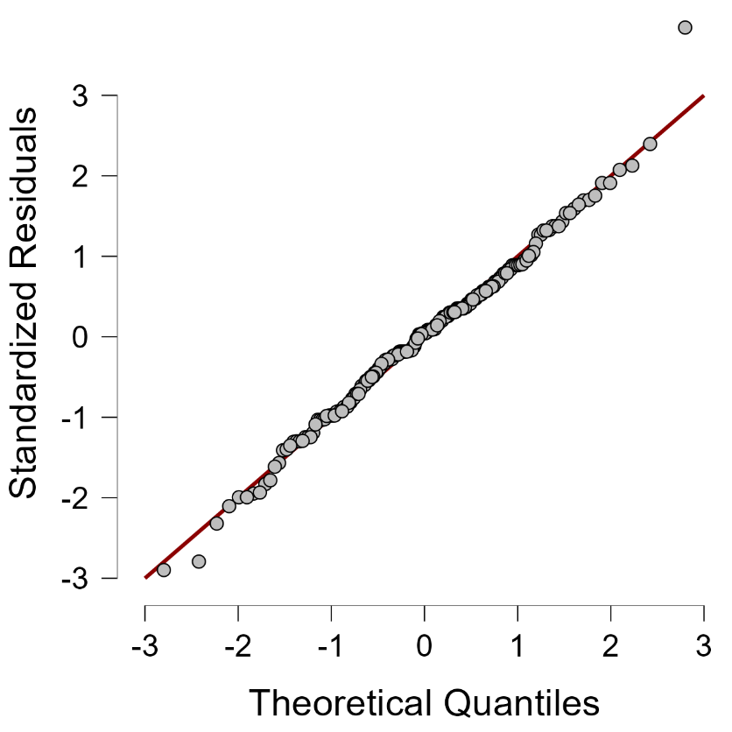

- Uji Hipotesis
Uji Hipotesis (Prediktor: Harapan akademik)
Model Summary - Grit akademik
Model |  | R |  | R² |  | Adjusted R² |  | RMSE
H₀ |  | 0.000 |  | 0.000 |  | 0.000 |  | 5.194
H₁ |  | 0.800 |  | 0.640 |  | 0.638 |  | 3.124

ANOVA
Model |  |  |  | Sum of Squares |  | df |  | Mean Square |  | F |  | p
H₁ |  | Regression |  | 3332.423 |  | 1 |  | 3332.423 |  | 341.532 |  | < .001
 |  | Residual |  | 1873.397 |  | 192 |  | 9.757
 |  | Total |  | 5205.820 |  | 193
Note. The intercept model is omitted, as no meaningful information can be shown.

Coefficients
Model |  |  |  | Unstandardized |  | Standard Error |  | Standardized |  | t |  | p
H₀ |  | (Intercept) |  | 43.314 |  | 0.373 |  |  |  | 116.163 |  | < .001
H₁ |  | (Intercept) |  | 12.939 |  | 1.659 |  |  |  | 7.800 |  | < .001
 |  | Harapan akademik |  | 0.836 |  | 0.045 |  | 0.800 |  | 18.481 |  | < .001

- Uji Asumsi Untuk Uji Tambahan
Tabel Grafik Residual vs Predicted Untuk Uji Hosmokedasitas

Residuals vs. Predicted
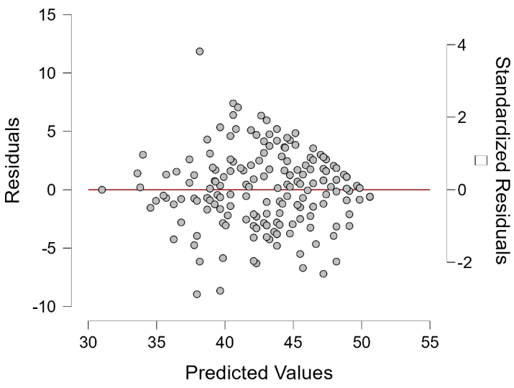
Tabel Grafik Residual vs Predicted Untuk Uji Normalitas dan Uji Linearitas

Q-Q Plot Standardized Residuals
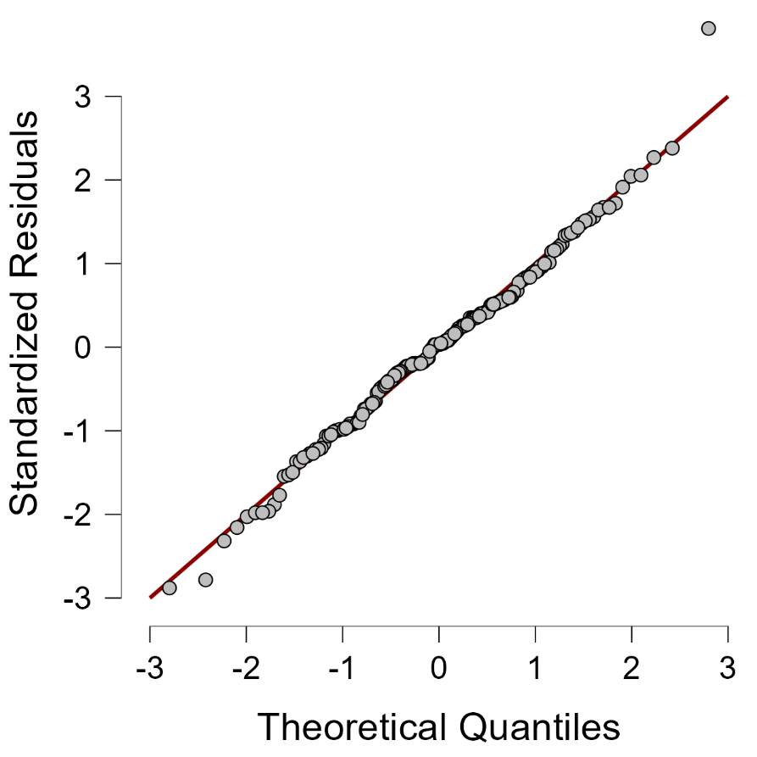

Uji Hipotesis, Uji Durbin Watson, Uji Multikolinearitas (Prediktor: Aspek Harapan akademik)
Model Summary - Academic grit
 |  |  |  |  |  |  |  |  |  | Durbin-Watson
Model |  | R |  | R² |  | Adjusted R² |  | RMSE |  | Autocorrelation |  | Statistic |  | p
1 |  | 0.000 |  | 0.000 |  | 0.000 |  | 5.194 |  | -0.031 |  | 2.041 |  | 0.772
2 |  | 0.735 |  | 0.540 |  | 0.537 |  | 3.532 |  | 0.030 |  | 1.933 |  | 0.640
3 |  | 0.801 |  | 0.642 |  | 0.638 |  | 3.124 |  | 0.065 |  | 1.862 |  | 0.338

Coefficients
 |  |  |  |  |  |  |  |  |  |  |  |  |  | Collinearity Statistics
Model |  |  |  | Unstandardized |  | Standard Error |  | Standardized |  | t |  | p |  | Tolerance |  | VIF
1 |  | (Intercept) |  | 43.314 |  | 0.373 |  |  |  | 116.163 |  | < .001
2 |  | (Intercept) |  | 17.599 |  | 1.732 |  |  |  | 10.161 |  | < .001
 |  | Pathway |  | 1.596 |  | 0.106 |  | 0.735 |  | 15.009 |  | < .001 |  | 1.000 |  | 1.000
3 |  | (Intercept) |  | 12.845 |  | 1.662 |  |  |  | 7.728 |  | < .001
 |  | Pathway |  | 0.951 |  | 0.128 |  | 0.438 |  | 7.405 |  | < .001 |  | 0.536 |  | 1.865
 |  | Agency |  | 0.750 |  | 0.102 |  | 0.436 |  | 7.374 |  | < .001 |  | 0.536 |  | 1.865

