GUNADARMA UNIVERSITY
FACULTY OF LETTERS AND CULTURES
ENGLISH LITERATURE DEPARTMENT


THE ANALYSIS OF IMPOLITENESS STRATEGIES AND ITS SPEECH ACTS OF MAIN ANTAGONIST CHARACTER IN CRUELLA MOVIE

Written by:
Name : Wildaan Mukhallad
NPM : 17618334
Major : English Literature
Advisor : Dr. Agung Prasetyo Wibowo, S.S., M.Sas.

An Undergraduate Thesis
Submitted to the Faculty of Letters and Cultures
As a Partial Fulfillment of the Requirements for
Undergraduate Degree in English Literature Department

JAKARTA
2022

PAGE OF APPROVAL
Board of Advisors
No. | Name | Position
1. | Dr. Agung Prasetyo Wibowo, S.S., M.Sas. | Chairman
2. | Dr. Dwi Nitisari, S.S., M.Sas. | Member
3. | Dyah Ambar Wuryandari, S.S., M.Hum. | Member
Date of Examination: September 13th, 2022

Board of Examiners
No. | Name | Position
1. | Dr. Ravi Ahmad Salim | Chairman
2. | Prof. Dr. Wahyudi Priyono | Secretary
3. | Dr. Agung Prasetyo Wibowo, S.S., M.Sas. | Member
4. | Dr. Dwi Nitisari, S.S., M.Sas. | Member
5. | Dyah Ambar Wuryandari, S.S., M.Hum. | Member
Passing Date: September 13th, 2022

Approved by:

Advisor, Chair of Board of Examiners,

(Dr. Agung Prasetyo Wibowo, S.S., M.Sas.) (Dr. Edi Sukirman, S.Si., M.M., M.Ikom.)

ABSTRACT
Wildaan Mukhallad. The Analysis of Impoliteness Strategies and Its Speech Acts of Main Antagonist Character in Cruella Movie. An Undergraduate Thesis. English Literature Department. Faculty of Letters and Cultures. Gunadarma University. Jakarta. 2022.
This research discusses about impoliteness strategies and its speech acts performed in the impolite utterances of main antagonist character in Cruella movie. The objectives of this research are to find out the impoliteness strategies in the utterances of main antagonist character in Cruella movie using Culpeper’s impoliteness strategies (1996) and to find out the speech acts in the impolite utterances of main antagonist character in Cruella movie using Searle’s classification of speech acts (1979). The method of this research is descriptive qualitative method. The source of data of this research is a movie entitled Cruella. This research uses the script dialogue of Cruella movie from Disney+ Hotstar as the data. The result shows that there are 90 data found in this research consisting of five impoliteness strategies and five classification of speech acts in the utterances of main antagonist character in Cruella movie. The impoliteness strategies found in this research are bald-on record impoliteness with 11 data or 12,22%, positive impoliteness with 18 data or 20%, negative impoliteness with 49 data or 54,44%, sarcasm or mock politeness with 8 data or 8,89%, and withhold politeness with 4 data or 4,44%. The classification of speech acts found in this research are declaration with 2 data 2,22%, representative with 22 data or 24,44%, commissive with 4 data or 4,44%, directive with 41 data or 45,56%, and expressive with 21 data 23,33%. The researcher found 16 combination of speech acts in impoliteness strategy shown in this research. They are declaration in positive impoliteness with 2 data or 2,22%, representative in bald-on record impoliteness with 7 data or 7,78%, representative in positive impoliteness with 8 data or 8,89%, representative in negative impoliteness with 4 data or 4,44%, representative in sarcasm or mock politeness with 2 data or 2,22%, representative in withhold politeness with 1 datum or 1,11%, commissive in negative impoliteness with 3 data or 3,33%, commissive in sarcasm or mock politeness with 1 datum or 1,11%, directive acts in bald-on record impoliteness with 4 data or 4,44%, directive in positive impoliteness with 6 data or 6,67%, directive in negative impoliteness with 30 data or 33,33%, directive act in sarcasm or mock politeness with 1 datum or 1,11%, expressive in positive impoliteness with 2 data or 2,22%, expressive in negative impoliteness with 12 data or 13,33%, expressive in sarcasm or mock politeness with 4 data or 4,44%, and expressive in withhold politeness with 3 data or 3,33%. Based on the result of this research, directive speech act in negative impoliteness strategy is the most frequent utterances performed by the main antagonist in Cruella movie.
Key word: Impoliteness Strategies, Speech Acts, Movie, Cruella

CURRICULUM VITAE
Name : Wildaan Mukhallad
Place/Date of Birth : Bekasi, October 9th, 1996
Religion : Islam
Address : Pondok Surya Mandala Blok L1 No.17
Phone : 082299059690

Educational Background:
- SD Negeri Jati Asih VIII, 2009
- SMP Islam Terpadu Iqro, 2012
- SMK Negeri 26 Jakarta, 2016
Registered as student at Gunadarma University, Faculty of Letters and Cultures Majoring English Literature Department in 2018

DECLARATION OF ORIGINALITY
I declare that this undergraduate thesis is the product of my own work. It has not been submitted before for any degree or examination in any other university, and that all the sources I have used or quoted have been indicated and acknowledged as complete references.

Bekasi, August 26th, 2022

Wildaan Mukhallad

PAGE OF DEDICATION
This undergraduate thesis is dedicated with gratitude and affection to the researcher’s parents, brother and sisters, teachers and lecturers, advisor, examiners, and people who supported and helped the researcher to finish this research.

PAGE OF MOTTO
“The Best Revenge is to Improve Yourself”

—Ali ibn Abi Talib

ACKNOWLEDGEMENTS
Praise be to Allah, the most gracious and the most merciful. Peace and blessing upon the Messenger of Allah, Prophet Muhammad—peace be upon him. The researcher would like to express gratitude to Allah for His blessing and inspiration leading the researcher to finish this undergraduate thesis.
The researcher also would like to thank to:
- Prof. Dr. E. S. Margianti, S.E., M.M., as the Rector of Gunadarma University.
- Dr. Dr. Ichwan Suyudi, M.M., as the Dean of Faculty of Letters and Cultures of Gunadarma University.
- Dr. Rita Sutjiati Djohan, M.Pd., as the Director of English Department of Faculty of Letters and Cultures of Gunadarma University.
- Dr. Edi Sukirman, S.Si., M.M., M.Ikom., as the Chair of Board of Examiners of Gunadarma University.
- Dr. Agung Prasetyo Wibowo, S.S., M.Sas., as the advisor who has patiently guided and given suggestions, advices, feedback, and knowledge to help the researcher finishing this research.
- Dr. Dwi Nitisari, S.S., M.Sas., as the examiner for this undergraduate thesis who has examined and helped the researcher to revise this research.
- Mrs. Dyah Ambar Wuryandari, S.S., M.Hum., as the examiner for this undergraduate thesis who has examined and helped the researcher to revise this research.
- All Lecturers in English Literature Department of Gunadarma University who have shared the knowledge to the researcher.
- Parents of the researcher, Dr. Djunaidi, M.Hum., and Elly Hastuti, M.Pd., who have been taking care of the researcher, giving the researcher all the privileges, and always supporting and praying for the researcher.

Finally, the researcher hopes this undergraduate thesis would be useful for everyone who reads it.

Wildaan Mukhallad

TABLE OF CONTENTS

TITLE i
PAGE OF APPROVAL ii
ABSTRACT ii
CURRICULUM VITAE iv
DECLARATION OF ORIGINALITY v
PAGE OF DEDICATION vi
PAGE OF MOTTO vii
ACKNOWLEDGEMENTS viii
TABLE OF CONTENTS ix
LIST OF FIGURES xii

CHAPTER 1 INTRODUCTION 1
1.1 Background of the Research 1
1.2 Previous Research 4
1.3 Position of the Research 6
1.4 Scope of the Research 6
1.5 Problem of the Research 7
1.6 Objective of the Research 7
1.7 Significance of the Research 7

CHAPTER 2 REVIEW OF RELATED LITERATURE 9
2.1 Linguistics 9
2.2 Pragmatics 9
2.3 Speech Acts 10
2.3.1 Locutionary Acts 10
2.3.2 Illocutionary Acts 11
2.3.3 Perlocutionary Acts 11
2.4 Classification of Speech Acts 12
2.4.1 Declaration 12
2.4.2 Representative 13
2.4.3 Expressive 13
2.4.4 Directive 14
2.4.5 Commissive 14
2.5 Politeness 15
2.6 Face in Politeness 15
2.7 Impoliteness 16
2.8 Impoliteness Strategies 17
2.8.1 Bald-on Record Impoliteness 17
2.8.2 Positive Impoliteness 18
2.8.3 Negative Impoliteness 19
2.8.4 Sarcasm or Mock Politeness 19
2.8.5 Withhold Politeness 20
2.9 Overview of the Movie 20

CHAPTER 3 RESEARCH METHOD 22
3.1 Research Design 22
3.2 Source of the Data 22
3.3 Data Collection Procedure 22
3.4 Data Analysis Procedure 23

CHAPTER 4 RESULT OF THE RESEARCH 24
4.1 Result 24
4.1.1 Impoliteness Strategies in the Utterances of Main Antagonist Character in Cruella Movie 24
4.1.1.1 Bald-on Record Impoliteness 25
4.1.1.2 Positive Impoliteness 27
4.1.1.3 Negative Impoliteness 30
4.1.1.4 Sarcasm or Mock Politeness 32
4.1.1.5 Withhold Politeness 34
4.1.2 Speech Acts in the Impolite Utterances of Main Antagonist Character in Cruella Movie 36
4.1.2.1 Declaration 37
4.1.2.2 Representative 39
4.1.2.3 Commissive 41
4.1.2.4 Directive 44
4.1.2.5 Expressive 46
4.2 Discussion: Speech Acts in Each Impoliteness Strategy 48
4.2.1 Declaration in Positive Impoliteness 50
4.2.2 Representative in Bald-on Record Impoliteness 50
4.2.3 Representative in Positive Impoliteness 51
4.2.4 Representative in Negative Impoliteness 52
4.2.5 Representative in Sarcasm or Mock Politeness 53
4.2.6 Representative in Withhold Politeness 54
4.2.7 Commissive in Negative Impoliteness 55
4.2.8 Commissive in Sarcasm or Mock Politeness 56
4.2.9 Directive in Bald-on Record Impoliteness 57
4.2.10 Directive in Positive Impoliteness 58
4.2.11 Directive in Negative Impoliteness 59
4.2.12 Directive in Sarcasm or Mock Politeness 60
4.2.13 Expressive in Positive Impoliteness 61
4.2.14 Expressive in Negative Impoliteness 62
4.2.15 Expressive in Sarcasm or Mock Politeness 63
4.2.16 Expressive in Withhold Politeness 64

CHAPTER 5 CONCLUSION AND SUGGESTION 66
5.1 Conclusion 66
5.2 Suggestion 67

REFERENCES 68
APPENDICES

LIST OF FIGURES
Figure 4.1 Impoliteness Strategies in the Utterances of Main Antagonist Character in Cruella Movie 23
Figure 4.2 Scene Taken from 00:36:16,134 --> 00:36:27,104 24
Figure 4.3 Scene Taken from 00:42:22,125 --> 00:42:24,920 25
Figure 4.4 Scene Taken from 01:06:14,057 --> 01:06:18,645 26
Figure 4.5 Scene Taken from 00:29:41,990 --> 00:29:45,452 26
Figure 4.6 Scene Taken from 00:41:19,438 --> 00:41:28,071 27
Figure 4.7 Scene Taken from 01:15:33,992 --> 01:15:42,292 28
Figure 4.8 Scene Taken from 00:35:51,318 --> 00:36:02,538 29
Figure 4.9 Scene Taken from 01:12:24,261 --> 01:12:26,847 30
Figure 4.10 Scene Taken from 02:01:08,519 --> 02:01:19,738 30
Figure 4.11 Scene Taken from 00:37:16,570 --> 00:37:23,702 31
Figure 4.12 Scene Taken from 00:48:38,544 --> 00:48:45,717 32
Figure 4.13 Scene Taken from 01:59:11,276 --> 01:59:19,618 33
Figure 4.14 Scene Taken from 00:38:56,837 --> 00:39:01,925 34
Figure 4.15 Scene Taken from 00:49:06,572 --> 00:49:10,951 34
Figure 4.16 Scene Taken from 01:14:38,145 --> 01:14:44,693 35
Figure 4.17 Speech Acts in the Impolite Utterances of Main Antagonist Character in Cruella Movie 36
Figure 4.18 Scene Taken from 00:33:53,825 --> 00:33:55,410 37
Figure 4.19 Scene Taken from 01:12:04,575 --> 01:12:10,956 37
Figure 4.20 Scene Taken from 00:36:28,480 --> 00:36:30,524 38
Figure 4.21 Scene Taken from 01:10:32,858 --> 01:10:43,869 39
Figure 4.22 Scene Taken from 01:15:27,319 --> 01:15:28,654 40
Figure 4.23 Scene Taken from 01:12:44,531 --> 01:12:56,168 41
Figure 4.24 Scene Taken from 01:27:11,023 --> 01:27:22,367 41
Figure 4.25 Scene Taken from 02:01:08,519 --> 02:01:19,738 42
Figure 4.26 Scene Taken from 00:29:41,990 --> 00:29:45,452 43
Figure 4.27 Scene Taken from 00:37:35,464 --> 00:37:38,383 44
Figure 4.28 Scene Taken from 00:48:48,554 --> 00:48:50,722 44
Figure 4.29 Scene Taken from 00:42:08,654 --> 00:42:12,449 45
Figure 4.30 Scene Taken from 01:37:53,040 --> 01:38:06,553 46
Figure 4.31 Scene Taken from 01:38:22,528 --> 01:38:26,532 47
Figure 4.32 Speech Acts Found in each Impoliteness Strategies of Main Antagonist Character in Cruella Movie 48
Figure 4.33 Scene Taken from 01:12:04,575 --> 01:12:10,956 49
Figure 4.34 Scene Taken from 00:36:16,134 --> 00:36:27,104 50
Figure 4.35 Scene Taken from 00:41:19,438 --> 00:41:28,071 51
Figure 4.36 Scene Taken from 00:30:01,844 --> 00:30:03,011 52
Figure 4.37 Scene Taken from 00:37:16,570 --> 00:37:23,702 53
Figure 4.38 Scene Taken from 00:38:56,837 --> 00:39:01,925 54
Figure 4.39 Scene Taken from 02:01:08,519 --> 02:01:19,738 55
Figure 4.40 Scene Taken from 01:29:21,862 --> 01:29:28,952 56
Figure 4.41 Scene Taken from 00:42:22,125 --> 00:42:24,920 57
Figure 4.42 Scene Taken from 00:29:41,990 --> 00:29:45,452 58
Figure 4.43 Scene Taken from 00:35:51,318 --> 00:36:02,538 59
Figure 4.44 Scene Taken from 01:21:34,144 --> 01:21:42,444 59
Figure 4.45 Scene Taken from 00:42:08,654 --> 00:42:12,449 60
Figure 4.46 Scene Taken from 01:38:22,528 --> 01:38:26,532 61
Figure 4.47 Scene Taken from 00:48:38,544 --> 00:48:45,717 62
Figure 4.48 Scene Taken from 01:14:38,145 --> 01:14:44,693 63

CHAPTER 1

INTRODUCTION

Background of the Research
Humans are social creatures who interact by communicating to convey ideas, express emotions, and tell their desires to others. To fulfill the purpose of social interaction, humans use language as a communication tool that can support all their social activities. Communication using language can be found in daily conversations between an utterer and an interlocutor. In the conversation, the utterer performs a certain action in his or her utterance to the interlocutor. The interlocutor then interprets utterer’s utterance to understand the intention and the purpose of the utterer’s action. This term is known as a speech act.
A speech act or also commonly referred to as a language act or linguistic act according to Searle in Markoem (2017, p. 237) is a speaking activity performed by someone by stating an utterance, such as a notification, command, regret, or congratulating, always followed by a speech act of certain actions or intentions. Speech act is used as a unit of analysis to obtain a resolution of the inability of the truth condition as the only measure that is determined as a criterion of truth or utterance. In pragmatic studies, the analysis of a discourse is not only in the scope of sentence or utterance analysis but also involves speech act.
In addition to speech act, in a conversation there must be some kind of cooperation between the utterer and the interpreter. Cooperation between the parties involved in the conversation is carried out for the sake of running language activities and speaking well in communication practices (Rahardi, Setyaningsih, & Dewi, 2018, p. 53). Therefore, Grace in Yule (2018, p. 64) says that it is important to understand the cooperative principle as assumptions that are not stated in a conversation. These principles are stated in conversational maxims.
In actual communication practice, Grice’s cooperative principle (1975) in speech alone cannot always be applied. In the practice of conversation, there are certain goals that result in intentionally violating the cooperative principle. The cultural diversity and social behavior of the people who are different and apply specifically make the maxims formulated in the principle of cooperation cannot be applied as they are. According to Rahardi (2018, p. 58), the principle of cooperation that used to be universal in every language, has to be reinterpreted.
Cooperating in conversation must be followed by social rules so that the purpose of the speech act can be achieved. Conversations between the utterer and the interlocutor must pay attention to the existing social rules, namely politeness. According to Leech (2021, p. 206), politeness relates to the relationship between two participants, namely self and other. Tarigan (2015, p. 75) also stated that in conversation, self means the speaker, and the other means the listener; but speakers also show politeness to third groups who may or may not be present in the said situation. To complement the cooperative principle which in practice cannot always be applied as it is, Leech (1983) formulated the politeness principle contained in the maxims of politeness so that it can be applied in speech act situations that refer to certain social rules.
To apply the politeness principle described by Leech (1983), it is necessary to have a relationship between the maxim of politeness and the categorization of speech acts in order to determine which maxims are appropriate and which speech acts are appropriate. Therefore, linguists in the field of semantics and pragmatics studied it and found a theory known as the theory of face saving act. According to Yule (2018, p. 104), face refers to a person’s social and emotional meaning that is expected to be known by others. As a technical term, the face is a person’s personal form in society. Markoem (2017, p. 280) also stated that the face referred to in this theory is the dignity that a person has.
In a conversation, the utterer has the potential to attack the opponent’s face and vice versa where the conversation occurred becomes a kind of competition that threatens each other. This act is known as a face threatening act (Yule, 2018, p. 106). To avoid the threat occurred, the utterer can say something that can reduce or even prevent the threat. This action is known as a face saving act. To answer this problem, Brown and Levinson (1987) described preventive measures against these threats, known as politeness strategies.
In the practice of conversation that has a specific purpose, impoliteness is often found in speech. Actions that are intended to threaten or attack the face of the interlocutor are deliberately carried out to create conflict and social disharmony. Culpeper (2011) explained in detail that impoliteness can occur if in communicating using language, the utterer does have the intention to attack or threaten the face of the interlocutor. Culpeper’s impoliteness strategies (1996) are the alternative actions to Brown and Levinson's (1987) theory of politeness strategies.
Besides being found in daily communication, speech acts in impoliteness strategies can also be found in literary works. One of them is through movie. Movie is defined as a branch of art that uses audio and visual as its medium. According to Parera (2004, p. 224), movie is a literary discourse and belongs to a group of expressive discourses. Movie can act as language communication. Movie has multiple functions, apart from being a form of entertainment, as well as a medium of communication to convey messages from the author to the audience.
Based on the description above, the researcher conducted further investigation of impoliteness strategies applied in utterances of main antagonist character and the identification of speech acts performed in the impolite utterances of main antagonist character in Cruella movie. Cruella is a movie produced by Walt Disney. This movie was released in May 2021, directed by Craig Gillespie. Cruella was also nominated for the Oscars Award 2022 and won for the category of the best costume design.
This research focuses on investigating the impoliteness strategies using Culpeper’s impoliteness strategies (1996) in the utterances of main antagonist character applied in Cruella movie then the results of the analysis are used as the data to identify the speech acts using Searle’s classification of speech acts (1979) performed in Cruella movie. As described in the explanation above, the researcher conducted this research because speech acts and impoliteness strategies are pragmatics study commonly found and performed in daily conversation but they are still rarely used as a topic of research discussion.
Culpeper’s theory of impoliteness strategies (1996) and Searle’s theory of speech acts (1979) are frequently used by previous researchers in related research. Therefore, this theories are appropriate to be used as the basis for analyzing this research. The reason why researcher used the utterances of main antagonist character as the source of data is because the utterances of this character have a lot of potential data of impoliteness strategies and the speech acts to be explored and analyzed. The movie is also interesting to be used as the source of data because this movie won Oscar Award 2022 for the category of the best costume design. This research also fulfilled the element of exclusivity because there has been no research that discusses the topic of impoliteness strategies and speech in the Cruella movie.

Previous Research
This research cannot be separated from the influence of previous research which inspired the researcher to use it as reference material in the process of conducting this research. Apart from several scientific sources such as books and other research journals, the researcher used three previous studies related to the disciplines analyzed in this study. All three have similarities and differences with each other in this study which are described as follows:
1.2.1 Fatchur Rachman Bangkit Susanto. (2018). The Study of Impoliteness in the Prison Break Series. Sanata Dharma University Yogyakarta.
In this research, the researcher intended to know the impoliteness strategies and the types of speech acts used in the movie series. The researcher used a descriptive qualitative method to analyze the data and to describe the results of this analysis. This research uses Culpeper’s theory (2005) about the strategies of impoliteness and the types of speech acts by Searle (1979). Based on the results, there are 50 data of impoliteness strategies used in the two seasons of movie series. The researcher found the highest amount of speech acts data used is directives speech acts with 18 data (36%). Bald on record and positive impoliteness are the dominant strategies in this research with 14 data (28%) each. The researcher concluded that the combination of the speech acts and the impoliteness strategies used in the Prison Break movie series results bald on record in directives speech acts is the largest category with 10 data (20%).
1.2.2 Indah Permata Sari Siahaan. (2019). Impoliteness Strategies Used by Haters of Lady Gaga in Her Instagram Comments. University of Sumatera Utara Medan.
This research is aimed to find out the types of impoliteness strategies using Culpeper’s theory (1996) and the function of using impoliteness strategies. From the comments of Lady Gaga’s haters on Instagram, the researcher found 26 data from 20 haters using impoliteness strategies. The negative impoliteness strategy and positive strategy are equally the most frequent strategies with 10 data or 38.46% each of them. There are 4 data or 15.38% using bald on record impoliteness and 2 data or 7.69% for sarcasm strategy. The most frequent function is affective impoliteness with 17 data or 65.38%, the second is coercive impoliteness with 4 data or 15.38%, and the least is entertaining impoliteness with 5 data or 19.23%.
1.2.3 Ayu Krisdayanti. (2020). Impoliteness Strategies in Straight Outta Compton Movie. Muhammadiyah University of Surakarta.
This research was conducted to investigate the types of impoliteness strategies using Culpeper’s theory (1996) and the characters’ intention of using those types of impoliteness strategies using Searle’s theory of illocutionary acts (1979). The result shows that there are 136 impoliteness strategies used by the characters in the Straight Outta Compton movie. There are 103 data (76%) of positive impoliteness strategy, 22 data (16%) of negative impoliteness strategy, 9 data (7%) of bald-on record impoliteness strategy, and 2 data (1%) of sarcasm or mock politeness. The researcher found the characters’ intentions of using those impoliteness strategies, as follows: convincing, reporting, ordering, questioning, threatening, anger, like, dislike, sadness, boasting, praising, surprised, and blaming.

Position of the Research
Based on the description of the three previous studies, the researcher found the similarity and the difference among this research and the previous researches. From the first previous research, it has similarities with this research which focuses on finding out the impoliteness strategies in a movie using Culpeper’s impoliteness strategies (1996) and the types of speech acts using Searle’s speech acts (1979). The difference is the first previous research uses utterances from all characters in movie series entitled Prison Break as the source of data while this research specifically focuses on the utterances of main antagonist character in Cruella movie.
From the second previous research, it has similarity with this research in using the Culpeper’s impoliteness strategies (1996) to find out the strategies of impoliteness. This research has different source of data with the second previous research. In the second previous research, the previous research investigates the social media while this research investigates movie dialogue as the source of data. The second previous research also investigates the function of impoliteness strategies while this research identifies the classification of speech acts using Searle’s theory (1979) instead.
From the third previous research, it has similarity with this research in finding out the impoliteness strategies using Culpeper’s impoliteness strategies (1996) and the intentions of the speaker using Searle’s classification of speech acts (1979). The difference of the research is the third previous research uses the utterances of all characters in the Straight Outta Compton movie as the data source while this research specifically uses the utterances of main antagonist character in Cruella movie as the source of data.

Scope of the Research
This research only focuses on the analysis of impoliteness strategies and its speech of main antagonist character in Cruella movie using Culpeper’s impoliteness strategies (1996) and Searle’s classification of speech acts (1979).

Problem of the Research
The problems of this research based on background of the story are:
- What are the impoliteness strategies applied in the utterances of main antagonist character in Cruella movie based on Culpeper’s impoliteness strategies (1996)?
- What are the speech acts performed in the impolite utterances of main antagonist character in Cruella movie based on Searle’s classification speech acts (1979)?

Objective of the Research
The objectives of this research based on problem of the research are:
- To find out the impoliteness strategies which are applied in the utterances of main antagonist character in Cruella movie using Culpeper’s impoliteness strategies (1996).
- To find out the speech acts which are performed in the impolite utterances of main antagonist character in Cruella movie using Searle’s speech acts (1979).

Significance of the Research
- Theoretically
This research theoretically is expected to be useful for other researchers as the source of references for further research in analyzing and identifying the classification of speech acts using Searle’s theory (1979) and the impoliteness strategies using Culpeper’s theory (1996) in daily conversation or in any literary works especially in a movie.
- Practically
This research practically is expected to be useful for students or language practitioners to be more respective to the interlocutors by understanding the meaning of an utterance, the assumptions, the intentions or goals, and the kinds of action in a speech by performing Searle's classification of speech act (1979) so that they could prevent miscommunication in daily conversation. It is also expected for students and practitioners to be able to identify impolite utterances using impoliteness strategies by Culpeper's theory (1996) so that they could avoid impolite expressions and prevent the potential for conflict with the interlocutors in daily conversation. In certain cases and also for certain purposes, language practitioners who have understood impolite expression could perform them in a conversation to give a certain effect to the interlocutors.

CHAPTER 2

REVIEW OF RELATED LITERATURE

Linguistics
The definition of linguistics according to Kridalaksana (1982, p. 99) is a science of language or scientific investigation of language. According to Alek (2018), linguistics is a science that specifically studies all aspects related to the scope of language. Linguistics is the study of phenomena and all about systematic rules in language. Saussure in Hasibuan (2015, p. 24) viewed linguistics as a speech behavior and conventional language as a result of habits that have become conventions in society. According to Alek (2018, p. 19), the discipline of linguistics is a scientific activity related to language which in drawing conclusions or theories must be based on empirical data. From the definition of linguistics above, it can be concluded that linguistics is the study that examines the intricacies of language scientifically.
Linguistics as a study of science has many branches. Linguistics consists of several sub-disciplines that have a wide range of relationships in human life. This is because almost all human activities involve the use of linguistic objects, namely language. According to Pribady (2018, p. 29), the branch of linguistics consists of micro linguistics and macro linguistics. Micro linguistics is a pure linguistic study that includes phonology, morphology, syntax, semantics, and pragmatics, while macro linguistics is an interdisciplinary study of linguistics with other fields, such as sociolinguistics, psycholinguistics, ethnolinguistic, neurolinguistics, forensic linguistics, eco linguistics, etc. One of the sub-disciplines of linguistics which will be discussed further is pragmatics.

Pragmatics
Pragmatics is the study of language related to meaning in context. Context in the sense put forward by Rahardi, Setyaningsih, & Dewi (2018, p. 165) are things that must be understood jointly by utterers and interlocutors that are both non-linguistic and intra-linguistic. Yule (2018, p. 227) explained that context is the physical environment in which a word is used.
Tarigan (2015, p. 30) defined pragmatics as the study of relationship between language and context which is grammaticalized or encoded in a language structure. Rahardi (2019, p. 27) defined pragmatics as the newest branch of linguistics that deals with the issue of the speaker's intent, and the speaker's intention is manifested in the form of language. Meanwhile, according to Markoem (2017, p. 207), pragmatics involves the meaning between the speaker and the interlocutor. Pragmatics examines what contribution the context makes to meaning. Levinson in Markoem (2017, p. 209) detailed pragmatics into four sections; deixis, presupposition, speech act, and conversational implicature, without neglecting the principles of language use which are carried out based on grammatical rules. Based on the explanation above, it can be concluded that Pragmatics the study of relations between the context outside the language and the meaning of speech through interpretation of the situation in which it is spoken. This research will further focus on discussing pragmatics analysis in the study of speech acts and impoliteness strategies.

Speech Acts
The definition of speech acts was stated by Austin in Suhartono (2020, p. 37) as an activity to convey the intention through speech. Searle in Markoem (2017, p. 237) defined speech acts as speaking activities carried out by someone by stating utterances, such as notifications, orders, regrets, or congratulating, always accompanied by certain actions or intentions. Yule (2018, p. 82) explained that the utterances expressed by someone are not only contain grammatical structures, but also show certain actions which will be called as speech acts. Based on the explanation of experts above, speech acts are understood as actions taken by someone when uttering. Austin in Leech (2021, p. 316) divided speech acts into three basic components; locutionary acts, illocutionary acts, and perlocutionary acts.

Locutionary Acts
Austin in Markoem (2017, p. 237) described locutionary acts as a physical form of utterance that is arranged according to the grammatical rules of the speaker in which it contains a specific purpose. When someone is telling something, that person is not just saying what he is saying but actually doing something. In the utterance there is an implicit or explicit intention or a purpose. According to Austin in Cummings (2019, p. 9), locutionary acts are the same as saying certain sentences with certain meanings and certain references, which have the same meaning as traditional meanings. Here is an example of locutionary act in an utterance:
‘The fierce dog is in the garden.’
(Cummings, 2019)
In the example above, the utterer is producing a sentence that means there is a dog that has fierce behavior in the garden. It can be concluded that the utterer produces locutionary acts.

Illocutionary Acts
According to Austin in Markoem (2017, p. 237), illocutionary acts are the contents or intentions contained in locutionary acts, such as: conveying or obtaining information, ordering, stating, complaining, warning, praising, promising, thanking, or apologizing. Austin in Cummings (2019, p. 9) also explained that illocutionary acts are utterances that have a certain force. When utterers produce sentences that have certain meanings and references, they are also contributing certain types of interactional movements in communication. Here is an example of illocutionary act in an utterance:
‘The fierce dog is in the garden.’
(Cummings, 2019)
In the example above, the utterer is performing an illocutionary act in the form of warning someone to not come to the garden. In this case, the warning is the illocutionary force of the utterance.

Perlocutionary Acts
Austin in Markoem (2017, p. 237) defined perlocutionary acts as an act of encouraging or exerting influence on the interlocutor. Austin also explained if the illocutionary act uttered, such as convincing, persuading, or blocking succeeds in influencing the interlocutor to act, the utterer has committed a perlocutionary act. (Cummings, 2019, p. 10). Here is an example of perlocutionary act in an utterance:
‘The fierce dog is in the garden.’
(Cummings, 2019)
In the example above, if the utterer succeeds in preventing the interlocutor from entering the garden, then the speaker has performed a perlocutionary act through that utterance.
Based on the definition of the three connected dimensions of speech acts described by Austin in Markoem (2017), Searle (1979) concluded the speech acts consist of locutionary acts: the act of saying something, illocutionary acts: the act of doing something, and perlocutionary acts: the act of affecting someone.
From the three dimensions of speech acts mentioned above, according to Yule (2018, p. 84) the study of illocutionary acts is the most frequently discussed in the pragmatics field. Searle (1979) classified speech acts into five general functions which all of them will be elaborated in this discussion.

Classification of Speech Acts
As explained in the previous discussion, speech acts are actions that are shown by using utterances to communicate (Yule, 2018, p. 239). Searle (1979) classified speech acts into five general types of functions; declaration, representative, expressive, directive, and commissive.

Declaration
Declaration is a speech act that brings about a change in the way it is uttered. When using declarations, utterers change the world with their utterances (Yule, 2018, p. 92). Searle (1979) explained that the successful implementation of the illocutionary resulted in a match between the proposition and reality, for example appointing, excommunicating, declaring war, christening, dismissing, resigning, baptizing, firing, naming, sentencing, etc. For example:
‘You’re fired.’
(Damadika, 2021)
The utterance above is categorized into declaration because the utterer changed the interlocutor’s reality from an employed to unemployed person. The act of this utterance is firing someone.

Representative
Representative or also known as assertive is a speech act in which the utterers state what they believe or know (Yule, 2018, p. 92). Searle (1979) explained that in this illocutionary, utterers are bound to the truth of the propositions expressed, for example asserting, stating, claiming, believing, reminding, reporting, assuring, agreeing, predicting, insisting, hypothesizing, boasting, concluding or deducing, etc. For example:
‘Yes, everything’s good. Life is good.’
(Haucsa, Marzuki, Alek, & Hidayat, 2020)
The utterance above is categorized into representative because the utterer said something true about himself by stating his current condition. The act of this utterance is stating.

Expressive
Expressive is a speech act in which the utterers express their feelings or behavior. This act may be caused by something done by the utterer or interlocutor, but they all involve the utterer's experience (Yule, 2018, p. 93). Searle (1979) explained this illocutionary function expresses the psychological attitude of the utterer towards the conditions implied in the illocutionary such as thanking, congratulating, welcoming, forgiving, apologizing, praising, blaming, insulting, accusing, condoling, etc. Expressive act can also express a psychological state and can be statements of pleasure, pain, likes, dislikes, joy, or sorrow. For example:
‘That... was a lie. I apologize for that’
(Rosyadi, 2020)
The utterance above is categorized into expressive because the utterer adjusted his words with his feeling by apologizing to his interlocutor. The utterer realized and felt that he did something wrong to his interlocutor. The act of this utterance is apologizing.

Directive
Directive is a speech act that is used by the utterer to tell the interlocutor to do something that is the desire of the utterer (Yule, 2018, p. 93). Searle (1979) explained that directive aims to produce an effect of action taken by the interlocutor, for example asking, dismissing, commanding, requesting, questioning, inviting, ordering, begging, permitting, challenging, daring, advising, instructing, warning, suggesting, recommending, prohibiting, etc. For example:
‘Can you stay with me?’
(Hastuti, Utami, & Oswari, 2021)
The utterance above is categorized into directive because the utterer attempts to get the interlocutor to do something she wants by requesting the interlocutor to stay with the utterer. The act of this utterance is requesting.

Commissive
Commissive is a speech act that is understood by the utterers to bind themselves to future actions (Yule, 2018, p. 94). Searle (1979) explained that the utterer's goal is tied to an action in the future such as promising, offering, threatening, refusing, volunteering, swearing, etc. For example:
‘I will cuff you, I will drag you out of here in front of everyone.’
(Susanto, 2018)
The utterance above is categorized into commissive because the utterer threats the interlocutor with serious consequences if the interlocutor does not follow the utterer’s coercive order. The acts of this utterance are promising and threatening.

Politeness
In addition to the study of speech acts, the pragmatic phenomenon studied is the phenomenon of language politeness. Language politeness is an act of showing awareness when using spoken and written language to the dignity of others in language (Kridalaksana, 1982). According to Yule (2018, p. 235), politeness is the means employed to show awareness for another person's face so that it can be respected in society. Lakoff (1989, p. 102) defined politeness as an act of minimizing the potency of conflict and confrontation in discourse. It can be concluded by the definition of Leech (2021, p. 120) about politeness as a conflict avoidance strategy which can be measured by the degree of effort made to avoid conflict situations. Brown and Levinson in Rahardi (2018, p. 66) said that politeness of utterance can be measured by considering the social distance between utterer and interlocutor, utterer and interlocutor relative power, and degree of imposition between utterer and interlocutor.

Face in Politeness
In daily social interactions, people usually want their faces to be respected. The concept of face in the context of language politeness has the meaning as the image of a person in society (Yule, 2018, p. 230). Rahardi (2018, p. 167) stated that in essence, the face is a person's self-image whose honor is always guarded and endeavored not to be violated in the utterance. According to Brown and Levinson in Rahardi (2018, p. 66), politeness is basically an attempt to do face saving act.
Yule (2018, p. 106) defined face saving act as an act to avoid potential threats to a person's image in society. On the other hand, a speech or action that threatens a person's reputation in the society is known as a face threatening act. In general, people are expected to respect people’s face wants by adopting face-saving acts to avoid face threatening acts as a polite behavior or etiquette in a cultured society. Face essentially shows a person's self-esteem, which can be distinguished between positive and negative face (Rahardi, Setyaningsih, & Dewi, 2018, p. 66).
Yule (2018, p. 105) explained that in politeness discussions, a person has the hope that his good image and reputation in society will be respected and honored which is known as face want. When a person tries to do a face saving act to the other person, that person can pay attention to the wants of the positive face or the negative face of the other person. Negative politeness is awareness of the rights of others not to be disturbed and their needs to be independent, have freedom of action, and not be pressured by others. Positive politeness is the reflection of solidarity with others and their needs to be accepted, liked, and treated as members of the same group and knowing their desires are shared with others (2018, p. 107).

Impoliteness
Impoliteness is the opposite of politeness used to threaten or damage someone’s face. Impoliteness can be understood as an act that hinders or obstructs someone's face wants and desires (Rahardi, Setyaningsih, & Dewi, 2018, p. 66). According to Culpeper (2011, p. 254), impoliteness is an attitude or behavior that is contrary to the nature of politeness that occurs in a certain context. Bousfield in Utami (2019, p. 64) explained that impoliteness is a gratuitous act spoken by the utterer to threaten the face of the interlocutor so that it causes a deliberate conflict. It can be concluded that impoliteness is the opposite of politeness where in politeness there is an attempt to do a face saving act, while in impoliteness deliberately attempt to do a face-threatening act.
Intentional acts of impoliteness are associated with the power to do so. Culpeper in Sani and Suhandoko (2020, p. 29) stated that the more powerful people are, the more opportunities they have to receive politeness from powerless people and have a higher tendency to use impoliteness to people who are powerless. Thus, powerless people tend to get their face attacked and will likely accept or counter the more powerful utterer’s threats. Beebe in Sani and Suhandoko (2020, p. 29) mentioned that there are three functions of impoliteness as the exercise of power. The first is to appear as superior. Powerful people tend to have desire to dominate as a superior. They use impoliteness such as insulting and humiliating others to appear their power. The second is to get power over actions, such as by getting control of someone to do something or making someone not to do it. The third is to dominate the conversation, such as by using conversational management; interrupting the conversation, making someone to talk, making someone to stop talking, or hold the floor.

Impoliteness Strategies
Rahardi (2018, p. 168) defined politeness strategies as tactical ways used to express politeness in conversation. From the definition of the expert about politeness, impoliteness strategies can be defined as tactical ways used to express impoliteness in conversation. Culpeper’s strategy of impoliteness (1996) is parallel to but opposite to Brown and Levinson's politeness strategy (1987). Brown and Levinson (1987, p. 60) identified four politeness strategies; bald-on record strategy, positive politeness strategy, negative politeness strategy, and off-record strategy. Meanwhile, Culpeper (1996, pp. 356-358) identified five impoliteness strategies consisting of bald-on record impoliteness, positive impoliteness, negative impoliteness, sarcasm or mock politeness, and withhold politeness which will be further elaborated in the following discussion.

Bald-on Record Impoliteness
According to Culpeper (1996), bald-on record impoliteness is a strategy of threatening the interlocutor’s face directly, clearly, unambiguously, and concisely in circumstances where the utterer does not intend to maintain the interlocutor’s face. For example:
Sherlock : Shut up.
Lestrade : (startled) I didn’t say anything.
Sherlock : You were thinking. It’s annoying.
(Gunawan, 2017)
According to the utterance above, the utterer performs bald-on record impoliteness because the utterer tries to attack the interlocutor’s face directly. It can be seen that the utterer is directly asking the interlocutor to shut up. He attacks someone’s face directly using an unambiguous statement.

Positive Impoliteness
According to Culpeper (1996), positive impoliteness is a strategy that refers to acts intentionally deployed to attack interlocutor’s positive face. The following sub-strategies are categorized into positive impoliteness: 1) Ignore other interlocutors; fail to acknowledge the presence of others, 2) Exclude others from activities, 3) Disassociate from others, such as denying association or common ground with them, 4) Disinterested, unconcerned, and unsympathetic to others, 5) Use inappropriate identity markers such as using a title and surname when a close relationship pertains, or a nickname when a distance relationship pertains, 6) Use an obscure or secretive language such as mystifying others with jargon or using a code known to members in the group, but not the target, 7) Make others feel uncomfortable, 8) Use taboo words, swear words, or abusive profane language, 9) Call the other names: Use derogatory nominations. For example:
John : We’ve only just met and we’re gonna go and look at a flat?
Sherlock : Problem?
(Gunawan, 2017)
According to the utterance above, the utterer performs positive impoliteness because the utterer does not concern about the interlocutor’s opinion. The utterer does not answer the interlocutor’s question, instead he attacks the interlocutor’s positive face by answering the question with question ‘problem’.

Negative Impoliteness
According to Culpeper (1996), negative impoliteness is a strategy that related to acts which are intentionally aimed to attack the interlocutor’s negative face. The following sub-strategies are categorized into negative impoliteness: 1) Frighten, instill a belief that an action detrimental to others will occur, 2) Scorn, ridicule by emphasizing the speaker’s relative power, 3) Contemptuous, not treating others seriously, 4) Belittle others—e.g., using diminutives, 5) Invade others’ space—literally or metaphorically, 6) Explicitly associate others with a negative aspect, 7) Put others’ indebtedness on record. For example:
Kellerman : I will cuff you, I will drag you out of here in front of everyone.
(Susanto, 2018)
According to the utterance above, the utterer performs negative impoliteness because the utterer frightens the interlocutor a threat to trap him. The utterer attacks the interlocutor’s negative face by forcing him to do the utterer wants.

Sarcasm or Mock Politeness
According to Culpeper (1996), sarcasm or mock politeness is a politeness strategy which is obviously insincere, pretending, or looking polite just on the surface. The utterer conveys this strategy indirectly using sarcasm or ironies. This strategy is used to cause social disharmony as opposed to ridicule or sarcasm for social harmony. For example:
Jeff : Don’t it make you mad? Why can’t people just think?
Sherlock : Oh, I see. So you’re a proper genius too.
Jeff : Don’t look it, do I?
(Gunawan, 2017)
According to the utterance above, the utterer performs sarcasm or mock politeness because the utterer performs a sarcastic utterance when he is speaking to the interlocutor. The utterer uses the sarcastic utterance to attack and insult the interlocutor’s face by saying he is a genius but the meaning is the opposite.

Withhold Politeness
According to Culpeper (1996), withhold politeness is the absence of politeness because of the utterer’s negligence or intentional not doing the politeness strategy where it is expected such as being silent and not thanking the interlocutor after being treated well. For example:
Ray : The DA and the cops they’re all gonna call for your immediate release. They’re gonna demand it.
Hancock : (silent)
Ray : What are you doing? Sit down.
(Sani & Suhandoko, 2020)
According to the utterance above, the utterer performs withhold politeness because the utterer remains silent and left the conversation instead of thanking the interlocutor’s offer of help.

Overview of the Movie
Cruella—starred by Emma Stone as Cruella, is a movie produced by Walt Disney Studios that can be watched on the Disney+ Hotstar. This movie has a duration of 134 minutes with a genre of crime-thriller. It is a prequel to the iconic Disney movie 101 Dalmatians where Cruella de Vil is one of the iconic antagonist in the Disney movie.
This movie tells the story of Cruella as the main character. Set in London in the 1970s in the midst of the punk rock revolution, Cruella whose real name is Estella is a girl who is known to be smart, creative, unique, ambitious in the fashion world, and known to be rebellious which made her expelled from the school.
Estella is unique in her hair which is half black and half white. People around her found her strange, but Estella remained an energetic person and always saw the world from a unique perspective. Since childhood, she had a dream to become a famous designer when she grew up.
After losing her foster mother from a sad moment, Estella must survive on her own, until she finally meets two thieves, Horace—starred by Paul Hauser and Jasper—starred by Joel Fry. They became friends and grew up together. They survived by stealing together. Estella became the designer of every costume they used in the heist.
With the help of her two best friends, Estella finally succeeds in pursuing her dream of working in the fashion world and manages to meet and work for Baroness von Hellman—starred by Emma Thompson. At first she was happy until the moment when she found out that the Baroness was responsible for Catherine's death—starred by Emily Beecham, her foster mother.
Baroness von Helmman is the antagonist character in Cruella movie. She is a well-known designer figure in the fashion industry in the city of London at that time. She is a famous fashion legend and a chief of a couture house. The Baroness is described as an authoritarian figure with a strong stand. Her character is an arrogant, selfish attitude, and does anything to grind the ladder of success.
This movie focuses on showing the rivalry of two female characters through their abilities in the fashion sector. In this research, the utterances of Baroness can potentially become obtainable source of data in the research of impoliteness strategies and the classification of speech acts in the impolite utterances by referring to the characteristics of Baroness.

CHAPTER 3

RESEARCH METHOD

Research Design
The method applied in this research is a qualitative descriptive method. According to Sudaryanto, (1998, p. 62) descriptive method is a method that describes facts and data that are analyzed systematically, factually, and accurately. Subroto (1992, p. 7) explained that descriptive qualitative research is performed by taking careful notes on data in the form of words, sentences, discourses, pictures/photos, diaries, memorandums and videotapes. Sutopo (2006, p. 35) described descriptive qualitative research as research that focuses on data in the form of words, sentences, or pictures that have more meaning than numbers or frequencies. Based on the explanation from the experts regarding the qualitative descriptive method above, this research uses descriptive qualitative method to find out the impoliteness strategies in the utterances of main antagonist in Cruella movie using Culpeper's impoliteness strategies (1996) and to find out the speech acts in the impolite utterances of main antagonist using Searle's classification of speech acts (1979).

Source of Data and Data
The source of data in this research is a Disney movie entitled Cruella (2021) with the duration of 134 minutes. This movie is directed by Craig Gillespie, produced by Walt Disney Studios, and won for the category of the best costume design in Oscars Award 2022. This research focuses on finding out the impoliteness strategies and its speech acts of main antagonist character utterances in Cruella movie. The data of this research are the impolite utterances and speech act utterances of main antagonist character in the script dialogue of Cruella movie.

Data Collection Procedure
The researcher used data collection procedure to obtain the research data. The following steps are the procedure that the researcher used to collect the data:
- Watching the movie several times.
- Understanding the movie.
- Identifying the impolite utterances of main antagonist in the movie related to impoliteness strategies.
- Writing the impoliteness strategies appeared in the utterances of main antagonist.
- Identifying the speech acts in the impolite utterances that apply impoliteness strategies.
- Writing the speech acts performed in the impolite utterances of main antagonist.

Data Analysis Procedure
The researcher used data analysis procedure to process the research data. The following steps are the procedure that the researcher used to analyze the data:
- Classifying the identified impoliteness strategies as well as the speech acts in table of data.
- Analyzing the classified data related to Culpeper’s theory of impoliteness strategies.
- Analyzing the classified data related to Searle’s theory of speech acts.
- Analyzing the speech acts found in each impoliteness strategy.
- Concluding the analyzed data.

CHAPTER 4

RESULT OF THE RESEARCH

Result
This chapter discusses the research findings of impoliteness strategies and its speech acts of main antagonist character utterances in Cruella movie. The following discussion will describe in detail the findings of impoliteness strategies and its speech acts.

Impoliteness Strategies in the Utterances of Main Antagonist Character in Cruella Movie
Impoliteness strategies can be defined as tactical ways used to express impolite utterance in conversation. In this research, there are five impoliteness strategies found in the utterances of main antagonist character in Cruella movie. There are 90 data found in five impoliteness strategies applied by the main antagonist character in her utterances. They are bald-on record impoliteness with 11 data or 12,22%, positive impoliteness with 18 data or 20%, negative impoliteness with 49 data or 54,44%, sarcasm or mock politeness with 8 data or 8,89%, and withhold politeness with 4 data or 4,44%. To make it easier to understand in describing the data by category, the following is a figure of impoliteness strategies applied by the main antagonist character in Cruella movie.
Figure 4.1 Impoliteness Strategies in the Utterances of Main Antagonist Character in Cruella Movie
The figure shows that negative impoliteness gets the highest percentage which means it is the most frequent impoliteness strategy and withhold politeness gets the lowest percentage which means it is the most infrequent impoliteness strategy applied by the main antagonist character. In the discussion below, it will be explained in detail about the analysis of impoliteness strategies applied by the antagonist character in Cruella movie.

Bald-on Record Impoliteness
Bald-on record impoliteness is performed when the utterer threatens interlocutor’s face directly, clearly, unambiguously, and concisely in circumstances where the utterer does not intend to maintain the interlocutor’s face. The researcher found 11 data of this impoliteness strategy in the utterances of main antagonist character in Cruella movie. They are on datum 1, 15, 16, 17, 18, 19, 35, 38, 43, 50 and 51. The researcher took three data of bald-on record impoliteness strategy to be presented in this research. The examples are as follow:
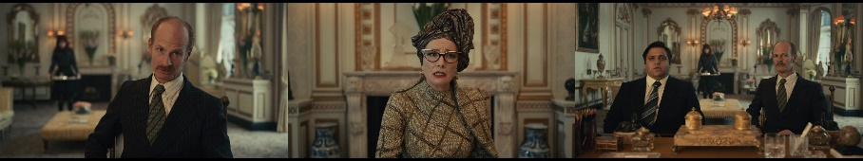
Datum 15
Baroness : My feedback. You’re short, you’re fat, you smell like an anchovy, you’re color-blind, but you pretend you aren’t.
Figure 4.2: Scene Taken from 00:36:16,134 --> 00:36:27,104
Description of the scene:
Men from department store that stock the Baroness product come to meet the Baroness. They intend to give input to the Baroness. Unfortunately, it turns backfired to them. Baroness straightforwardly humiliate them by telling the depravity of their work and how they can be incompetent in it.
Analysis:
Based on the datum above, bald-on record impoliteness strategy is performed by Baroness in her utterance because her utterance tells straightforwardly the real condition of her client as the interlocutor. In the Baroness’ utterance, it can be seen that she clearly wants to attack the interlocutor without considering the face aspect of the interlocutor.
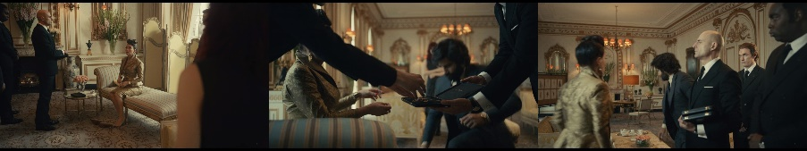
Datum 35
Baroness : Don’t touch the ankle.
Roger : Yes, sorry. It’s in.
Figure 4.3: Scene Taken from 00:42:22,125 --> 00:42:24,920
Description of the scene:
Roger put shoes on Baroness, but Baroness does not seem to like it when Roger touches her ankle.
Analysis:
Based on the datum above, bald-on record impoliteness strategy is performed by Baroness in her utterance because she does not only tell roger not to touch her ankle but she directly forbids it so that roger who does not have any intentions becomes exposed to threats from Baroness.
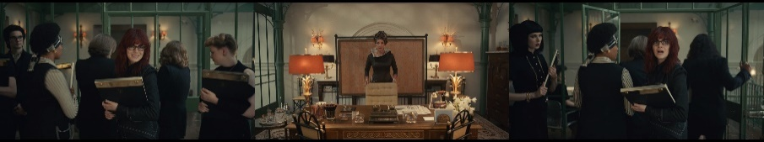
Datum 51
Estella : Oh. Good advice, thanks.
Baroness : What did I just say?
Estella : Uh, don’t thank you, so…
Figure 4.4: Scene Taken from 01:06:14,057 --> 01:06:18,645
Description of the scene:
All the designers are leaving the room. Estella innocently expresses her gratitude which Baroness does not really need and does not care about it.
Analysis:
Based on the datum above, bald-on record impoliteness strategy is performed by Baroness in her utterance because she directly responds to Estella with question that clearly tends to threaten Estella.

Positive Impoliteness
Positive impoliteness is performed when the utterer acts intentionally deployed to attack interlocutor’s positive face. The researcher found 18 data of this impoliteness strategy in the utterances of main antagonist character in Cruella movie. They are on datum 2, 9, 11, 12, 13, 24, 31, 33, 39, 46, 54, 58, 60, 65, 69, 70, 71, and 84. The researcher took three data of positive impoliteness strategy to be presented in this research. The examples are as follow:
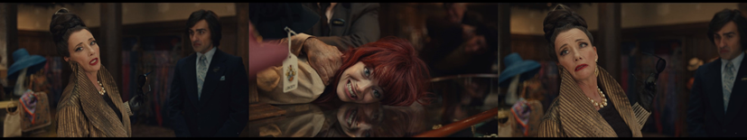
Datum 2
Baroness : You. Grubby girl.
Estella : Yes?
Figure 4.5: Scene Taken from 00:29:41,990 --> 00:29:45,452
Description of the scene:
Baroness calls Estella because Baroness curious with the creator who made the artistic window display at the Liberty. Baroness did not know Estella’s real name before because this is the first time they meet each other.
Analysis:
Based on the datum above, positive impoliteness strategy is performed by Baroness in her utterance because Baroness calls Estella by other name that represents her shabby look instead of asking Estella her real name. By conducting it, Baroness has attacked Estella’s positive face. This strategy is also classified into sub-strategy: call the other names: Use derogatory nominations.
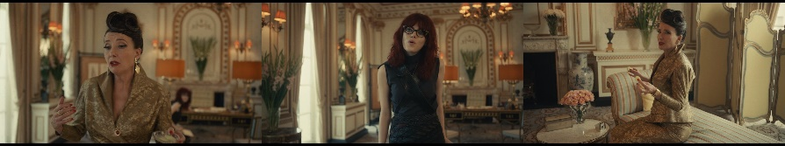
Datum 31
Estella : Who was the woman?
Baroness : Not really the point of the story. The story’s about how lucky I am, but anyway, she had a kid.
Figure 4.6: Scene Taken from 00:41:19,438 --> 00:41:28,071
Description of the scene:
Estella notices the Baroness’ necklace and asks Baroness to tell about it. Estella is getting more curious about the story of the necklace.
Analysis:
Based on the datum above, positive impoliteness strategy is performed by Baroness in her utterance because Baroness tells about how important her story to be told instead of giving the answer to Estella’s question as she expected. By conducting it, Baroness has attacked Estella’s positive face. This strategy is also classified into sub-strategy: ignore other interlocutors; fail to acknowledge the presence of others.
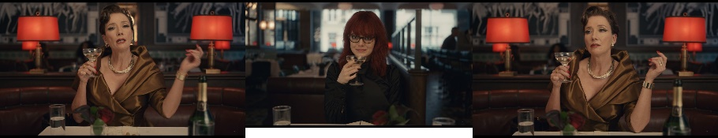
Datum 70
Baroness : Who the hell else would I drink to?
Estella : To me? For creating your signature piece?
Figure 4.7: Scene Taken from 01:15:33,992 --> 01:15:42,292
Description of the scene:
Baroness and Estella toast celebrating the new dress. Baroness says they celebrate for her. Estella scoffs by laughing at her. Estella says that she made the signature dress for Baroness so she deserves the praise and celebration.
Analysis:
Based on the datum above, positive impoliteness strategy is performed by Baroness in her utterance because Baroness does not involve Estella in celebrating moment. Baroness has a tendency to claim that everything is the result of her hard work instead of admitting the fact that it is Estella’s work. By conducting it, Baroness has attacked Estella’s positive face. This strategy is also classified into sub-strategy: exclude others from activities.

Negative Impoliteness
Negative impoliteness is performed when the utterer intentionally aims to attack the interlocutor’s negative face. The researcher found 49 data of this impoliteness strategy in the utterances of main antagonist character in Cruella movie. They are on datum 3, 4, 6, 7, 8, 10, 14, 20, 21, 23, 25, 26, 27, 29, 30, 32, 34, 36, 41, 42, 44, 48, 49, 52, 53, 55, 56, 57, 59, 61, 62, 63, 66, 67, 68, 73, 74, 75, 76, 78, 79, 80, 81, 83, 85, 86, 88, 89, and 90. The researcher took three data of negative impoliteness strategy to be presented in this research. The examples are as follow:
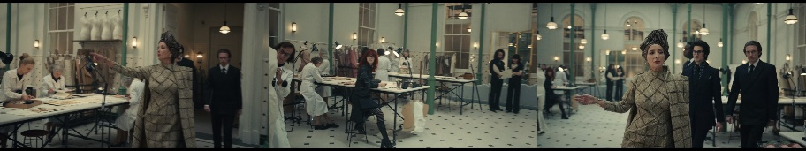
Datum 14
Baroness : Get me lunch. Soy salmon, lemon-zest risotto, cucumber sliced into two-inch diagonals at an eighth of an inch width sprinkled with seven leaves of parsley, shredded, not torn.
Estella : Right.
Figure 4.8: Scene Taken from 00:35:51,318 --> 00:36:02,538
Description of the scene:
The Baroness tells Estella to prepare lunch for her. The Baroness demands a super complicated lunch menu.
Analysis:
Based on the datum above, negative impoliteness strategy is performed by Baroness in her utterance because Baroness gives Estella the burden of responsibility for serving her by providing her lunch. By conducting it, Baroness has attacked Estella’s negative face. This strategy is also classified into sub-strategy: put others’ indebtedness on record.
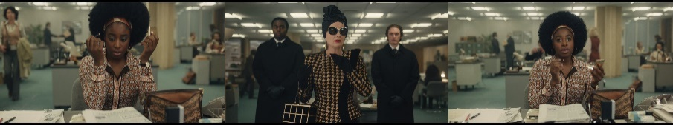
Datum 61
Baroness : You’ll need more than eyeliner, you plain little thing.
Figure 4.9: Scene Taken from 01:12:24,261 --> 01:12:26,847
Description of the scene:
Baroness and her men come to Tattletale's office. She throws the newspaper on Anita's table while Anita is doing her makeup.
Analysis:
Based on the datum above, negative impoliteness strategy is performed by Baroness in her utterance because Baroness criticizes Anita’s activity with unnecessary abuse. By conducting it, Baroness has attacked Estella’s negative face. This strategy is also classified into sub-strategy: scorn, ridicule by emphasizing the speaker’s relative power.
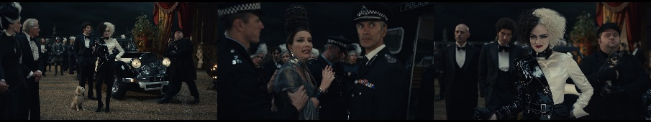
Datum 90
Baroness : She’s really Estella.
Cruella : Cruella de Vil.
Horace : It’s spelled “Devil,” but it’s pronounced “de Vil.”
Baroness : You wait, I’ll get even.
Figure 4.10: Scene Taken from 02:01:08,519 --> 02:01:19,738
Description of the scene:
After pushing Estella into the sea became known to the all witnesses, Baroness is arrested by the authorities. Estella, who has changed her character to Cruella, comes to the Baroness's residence to see her triumph. The baroness irritably explains to the people that the whole thing was Estella’s trick. Cruella smiles proudly for defeating the Baroness.
Analysis:
Based on the datum above, negative impoliteness strategy is performed by Baroness in her utterance because Baroness threatens Cruella even though she is not in the state of having that ability. By conducting it, Baroness has attacked Estella’s negative face. This strategy is also classified into sub-strategy: frighten, instill a belief that an action detrimental to others will occur.

Sarcasm or Mock Politeness
Sarcasm or mock politeness is performed when the utterer conveys something that is obviously insincere, pretending, or looking polite just on the surface. The researcher found 8 data of this impoliteness strategy in the utterances of main antagonist character in Cruella movie. They are on datum 5, 22, 37, 45, 72, 77, 82, and 87. The researcher took three data of sarcasm or mock politeness strategy to be presented in this research. The examples are as follow:
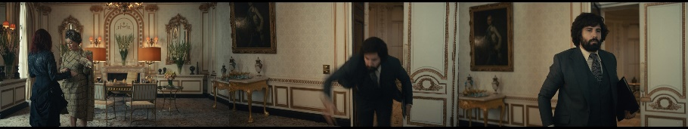
Datum 22
Baroness : Oh. Finally, someone competent.
Roger : Whoa!
Baroness : And someone not.
Figure 4.11: Scene Taken from 00:37:16,570 --> 00:37:23,702
Description of the scene:
Estella seems to have succeeded in bringing the lunch as the Baroness wanted. Roger comes stumbling.
Analysis:
Based on the datum above, sarcasm strategy is performed by Baroness in her utterance because Baroness compares one's behavior with others by praising one but in the same time also mocking others.
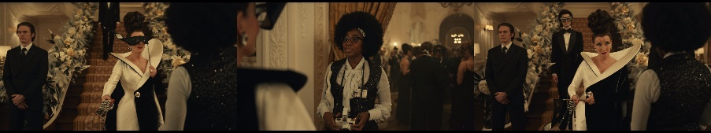
Datum 37
Anita : I’m so grateful you’ve given Tattletale an exclusive tonight.
Baroness : Not apparently grateful enough to observe the dress code.
Figure 4.12: Scene Taken from 00:48:38,544 --> 00:48:45,717
Description of the scene:
Baroness meets Anita in the party. Anita is working as a journalist of Tattletale Press to cover the event. Baroness does not like it when Anita wears wrong dress code.
Analysis:
Based on the datum above, sarcasm strategy is performed by Baroness in her utterance because Baroness expresses her displeasure by insinuating Anita's dress code and accusing her of being ungrateful.
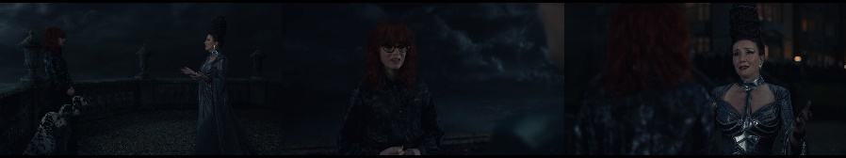
Datum 87
Cruella : You’re not going to push me off the cliff, are you?
Baroness : (WHISPERS) You’re so funny, dear. So funny.
Figure 4.13: Scene Taken from 01:59:11,276 --> 01:59:19,618
Description of the scene:
Baroness pretends to have just found out that Cruella is her biological child. She asks Cruella to come back to her. Baroness takes her daughter for a hug.
Analysis:
Based on the datum above, mock politeness strategy is performed by Baroness in her utterance because Baroness gives response to Cruella’s stupid question which obviously Baroness has tendency to be mean by flattering her.

Withhold Politeness
Withhold politeness is performed when the utterer does not conduct a politeness strategy either due to negligence or intentional as expected such as being silent and not thanking the interlocutor after being treated well. The researcher found 4 data of this impoliteness strategy in the utterances of main antagonist character in Cruella movie. They are on datum 28, 40, 47, and 64. The researcher took three data of withhold politeness strategy to be presented in this research. The examples are as follow:
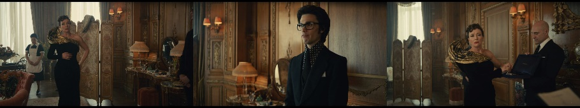
Datum 28
Baroness : All right, how do I look?
Jeffrey : Fabulous.
Baroness : Well, I know that.
Figure 4.14: Scene Taken from 00:38:56,837 --> 00:39:01,925
Description of the scene:
Baroness has finished changing and orders Jeffrey what he thinks of her appearance.
Analysis:
Based on the datum above, withhold politeness strategy is performed by Baroness in her utterance because Baroness does not thank Jeffrey about the compliment but she confidently expresses an agreement for that instead.
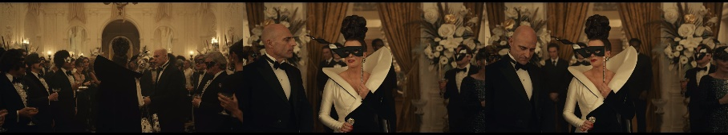
Datum 40
John : You look ravishing, Baroness.
Baroness : Master of understatement, as usual.
Figure 4.15: Scene Taken from 00:49:06,572 --> 00:49:10,951
Description of the scene:
John tells his opinion about Baroness’ look in the party. Baroness gets herself ready to greet the party guests.
Analysis:
Based on the datum above, withhold politeness strategy is performed by Baroness in her utterance because Baroness actually tells that John is very good at flattering her but she holds it by responding to John’s compliment with reverse compliment.
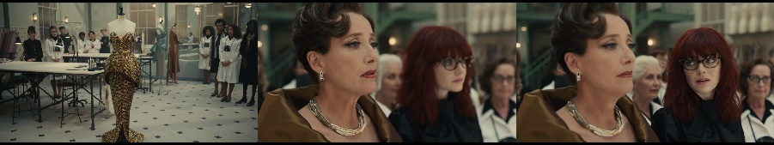
Datum 64
Baroness : It’s…
Estella : Stunning.
Baroness : Hmm.
Figure 4.16: Scene Taken from 01:14:38,145 --> 01:14:44,693
Description of the scene:
Estella was doing her job all night. She sewed the dress using gold trim. The next day Baroness is impressed looking the elegant dress.
Analysis:
Based on the datum above, withhold politeness strategy is performed by Baroness in her utterance because Baroness holds back her amazed expression by not finishing her sentence.

Speech Acts in the Impolite Utterances of Main Antagonist Character in Cruella Movie
Speech act can be defined as action that is shown by using utterance to communicate. In this research, there are five classification of speech acts found in the impolite utterances of main antagonist character in Cruella movie. There are 90 data found in five speech acts performed by the main antagonist character in her utterances. They are declaration with 2 data or 2,22%, representative with 22 data or 22,24%, commissive with 4 data or 4,44%, directive with 41 data or 45,56%, and expressive with 21 data or 23,33%. To make it easier to understand in describing the data by category, the following is a figure of speech acts performed by the main antagonist character in Cruella movie.
Figure 4.17 Speech Acts in the Impolite Utterances of Main Antagonist in Cruella Movie
The figure shows that directive gets the highest percentage which means it is the most frequent speech act and declaration gets the lowest percentage which means it is the most infrequent speech act performed by the main antagonist character. In the discussion below, it will be explained in detail about the analysis of speech acts performed by the antagonist character in Cruella movie.

Declaration
Declaration is the act intended by the utterer to create a new condition to the interlocutor, such as changes in status or circumstances. The researcher found 2 data of this speech act in the impolite utterances of main antagonist character in Cruella movie. They are on datum 9 and 60. The researcher took two data of declaration speech act to be presented in this research. The examples are as follow:
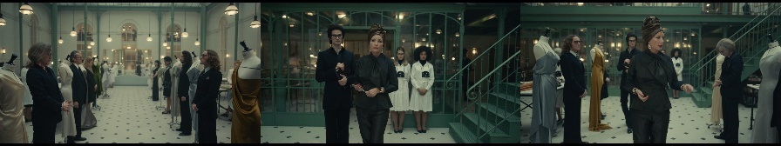
Datum 9
Baroness : Well, you’re fired.
Figure 4.18: Scene Taken from 00:33:53,825 --> 00:33:55,410
Description of the scene:
Baroness’ designers are lining up with their dress design displayed in mannequin. The situation is getting very intense. Baroness approaches one by one to assess the best design to be selected. All designers cannot fulfill Baroness’ criteria. They get bad ratings from Baroness.
Analysis:
Based on the datum above, the utterance is categorized into declaration act because Baroness in her capacity as a chief of couture house fires her fashion designer because she is not satisfied with the results of the designs. Baroness changed her designer’s status by her utterance. Baroness performs the act of firing.
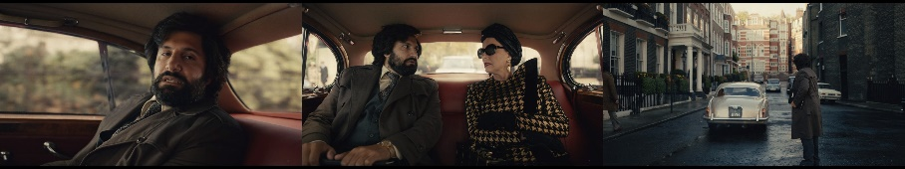
Datum 60
Roger : You do?
Baroness : So I have a gap to fire you. There’s a gap. You’re fired.
Figure 4.19: Scene Taken from 01:12:04,575 --> 01:12:10,956
Description of the scene:
Roger's opinion does not match the baroness's wishes so he is fired and kicked out of the car in the middle of the road by Baroness.
Analysis:
Based on the datum above, the utterance is categorized into declaration act because Baroness fires Roger to make him silent because she does not want to hear Roger’s opinion anymore. Roger's dismissal by the Baroness makes Roger no longer Baroness’ lawyer. Baroness performs the act of firing.

Representative
Representative is the act that binds the utterer to the truth of what the utterer says to interlocutor. The researcher found 22 data of this speech act in the impolite utterances of main antagonist character in Cruella movie. They are on datum 1, 4, 5, 15, 16, 17, 18, 19, 22, 24, 28, 31, 39, 44, 46, 50, 57, 58, 65, 69, 71, and 78. The researcher took three data of representative speech act to be presented in this research. The examples are as follow:
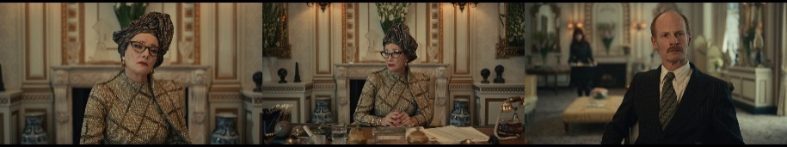
Datum 16
Baroness : You’re a man who can’t take responsibility.
Figure 4.20: Scene Taken from 00:36:28,480 --> 00:36:30,524
Description of the scene:
Men from departments store that stock the Baroness’ product come to meet Baroness. They intend to give input to the Baroness. Unfortunately, it turns backfired to them. Baroness straightforwardly humiliate them by telling the depravity of their work and how they can be incompetent in it.
Analysis:
Based on the datum above, the utterance is categorized into representative act because Baroness tells her opinion of her client with disdainful tendencies. Baroness performs the act of telling.
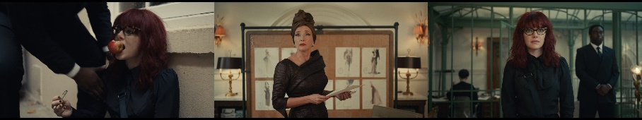
Datum 57
Baroness : Yes, I own the alley.
Estella : Really? You can own alleys?
Baroness : Alleys, designs, people, their souls. Check your employment contract.
Figure 4.21: Scene Taken from 01:10:32,858 --> 01:10:43,869
Description of the scene:
Estella was on her lunch break. She was also designing a dress. Suddenly the pad was taken by Baroness’ men. She was also dragged away to be brought before Baroness. Arriving at the Baroness room, Estella is surprised by what had happened. Baroness takes her design that Estella made to be displayed on the board as a new model for her spring collection.
Analysis:
Based on the datum above, the utterance is categorized into representative act because Baroness shows her power to Estella by stating that she possesses everything on her territorial. Baroness performs the act of claiming.
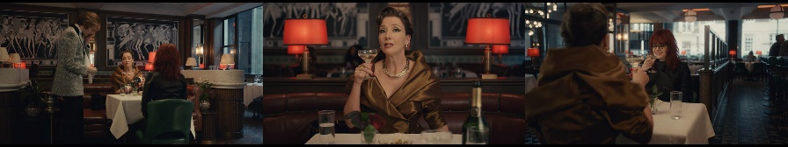
Datum 69
Baroness : Here’s to me.
Estella : (SCOFFS)
Figure 4.22: Scene Taken from 01:15:27,319 --> 01:15:28,654
Description of the scene:
Baroness and Estella toast the champagne celebrating the new dress. Baroness says that they are celebrating for her. Estella scoffs by laughing at her. Estella says that she made the signature dress for Baroness so she deserves the praise and celebration.
Analysis:
Based on the datum above, the utterance is categorized into representative act because Baroness thinks she deserves to get the celebration so she boasts herself of being successful but in fact she does not really contribute to it. Baroness performs the act of boasting.

Commissive
Commissive is the acts that binds the utterer to do what is stated in the utterer’s speech. The researcher found 4 data of this speech act in the impolite utterances of main antagonist character in Cruella movie. They are on datum 63, 75, 77, and 90. The researcher took three data of commissive speech act to be presented in this research. The examples are as follow:
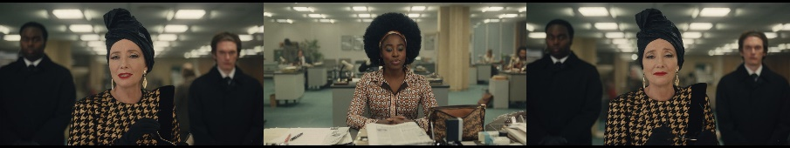
Datum 63
Anita : I… No, I…
Baroness : Don’t cry.
Anita : (SCOFFS) I’m not.
Baroness : You will. (BARONESS CHUCKLES)
Figure 4.23: Scene Taken from 01:12:44,531 --> 01:12:56,168
Description of the scene:
Baroness and her men come to Tattletale's office. She throws the newspaper on Anita's table while Anita is doing her makeup. Anita is shocked with Baroness’ presence. Baroness asks about Cruella through Anita but unfortunately Anita does not provide the answer that Baroness needs. Baroness threatens Anita and leaves the office.
Analysis:
Based on the datum above, the utterance is categorized into commissive act because Baroness intimidates Anita by making sure that Anita will going to be cry if she tries to play around with Baroness. Baroness performs the act of threatening.
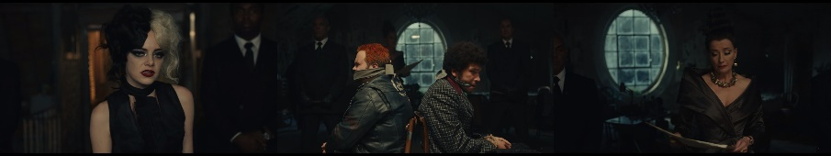
Datum 75
Cruella : This is between us. Let Jasper and Horace, imbeciles that they are for letting you follow them, let them go.
Baroness : Oh, I shall. They’re going to jail.
Figure 4.24: Scene Taken from 01:27:11,023 --> 01:27:22,367
Description of the scene:
Cruella arrives home after ruining the Baroness’ fashion show. She is surprised with Baroness and her men’ presence. Cruella also does not expect when finding out Horace and Jasper tied up. Cruella is subdued and tied with them. The baroness intends to report them to the police for the crimes they committed. The baroness sprinkled kerosene all over the room and set the building and Cruella on fire. Cruella is helpless in the flame that is keep spreading.
Analysis:
Based on the datum above, the utterance is categorized into commissive act because Baroness is willing to not involve Horace and Jasper in her rivalry with Cruella even though she still makes sure both of them are going to prison. Baroness performs the act of promising.
Datum 90
Baroness : She’s really Estella.
Cruella : Cruella de Vil.
Horace : It’s spelled “Devil,” but it’s pronounced “de Vil.”
Baroness : You wait, I’ll get even.
Figure 4.25: Scene Taken from 02:01:08,519 --> 02:01:19,738
Description of the scene:
After pushing Estella into the sea became known to the all witnesses, Baroness is arrested by the authorities. Estella, who has changed her character to Cruella, comes to the Baroness's residence to see her triumph. The baroness irritably explains to the people that the whole thing was Estella’s trick. Cruella smiles proudly for defeating the Baroness.
Analysis:
Based on the datum above, the utterance is categorized into commissive act because Baroness commits to payback for what Cruella did to her. Baroness performs the act of threatening.

Directive
Directive is the act performed by the utterer with the intention that the interlocutor does the actions mentioned in the utterance. The researcher found 41 data of this speech act in the impolite utterances of main antagonist character in Cruella movie. 2, 3, 6, 11, 12, 13, 14, 21, 23, 25, 26, 27, 29, 30, 32, 34, 35, 36, 38, 41, 42, 43, 48, 49, 51, 52, 53, 54, 55, 59, 66, 67, 68, 70, 72, 73, 74, 76, 81, 85, and 89. The researcher took three data of directive speech act to be presented in this research. The examples are as follow:
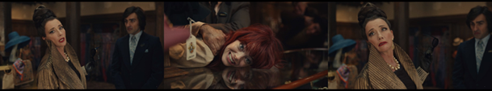
Datum 2
Baroness : You. Grubby girl.
Estella : Yes?
Figure 4.26: Scene Taken from 00:29:41,990 --> 00:29:45,452
Description of the scene:
Baroness calls Estella because Baroness curious with the creator who made the artistic window display at the Liberty.
Analysis:
Based on the datum above, the utterance is categorized into directive act because Baroness who previously did not know Estella’s name calls Estella by other name based on Estella’s appearance. Baroness calls Estella to make Estella gives her response. Baroness performs the act of calling.
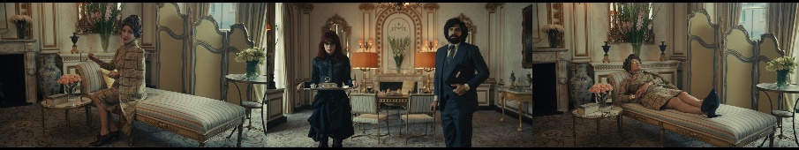
Datum 23
Baroness : Time for my nine-minute power nap. Box up my lunch, Estella. (GRUNTS)
Figure 4.27: Scene Taken from 00:37:35,464 --> 00:37:38,383
Description of the scene:
Baroness is going to take a nap. Baroness gives Estella an order to package the meal so Baroness can eat her lunch later.
Analysis:
Based on the datum above, the utterance is categorized into directive act because Baroness as the dominance gives Estella an order to do everything she asks for. Baroness performs the act of ordering.
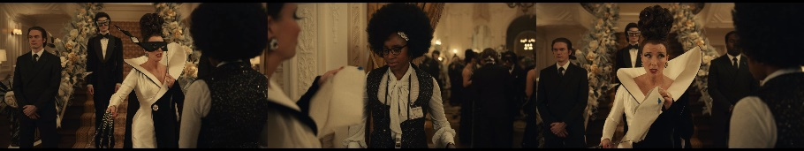
Datum 38
Baroness : No color.
Figure 4.28: Scene Taken from 00:48:48,554 --> 00:48:50,722
Description of the scene:
Baroness throws a party where all the invited guests wear black and white. Baroness does not like people who use flashy colors. When Baroness meets Anita, the Baroness sees Anita carrying a bag with a blue spot. The Baroness who does not seem happy about it takes Anita's bag from her.
Analysis:
Based on the datum above, the utterance is categorized into directive act because Baroness forbids Anita from wearing clothes other than black and white in her party. Baroness performs the act of prohibiting.

Expressive
Expressive is the act intended by the utterer so that the utterance is interpreted as an evaluation of the things mentioned in the speech where the utterer expresses the utterer’s feelings or behavior. The researcher found 21 data of this speech act in the impolite utterances of main antagonist character in Cruella movie. They are on datum 7, 8, 10, 20, 33, 37, 40, 45, 47, 56, 61, 62, 64, 79, 80, 82, 83, 84, 86, 87, and 88. The researcher took three data of expressive speech act to be presented in this research. The examples are as follow:
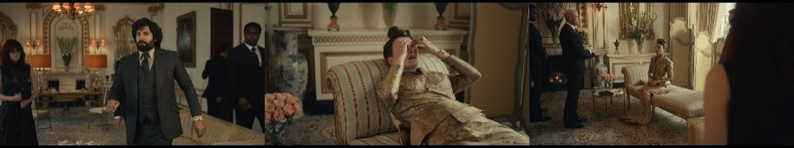
Datum 33
Roger : Baroness, we have that meeting at the Ritz.
Baroness : Oh, for heaven’s sakes. (SIGHS)
Figure 4.29: Scene Taken from 00:42:08,654 --> 00:42:12,449
Description of the scene:
Roger interrupts Baroness in her nap to let her know she has a meeting. Baroness feels annoyed, so she throws slices of cucumber to Roger which she used to cover her eyes.
Analysis:
Based on the datum above, the utterance is categorized into expressive act because Baroness expresses her annoyance to Roger for having her nap disturbed by Roger's presence. She curses to express her reaction. Baroness performs the act of cursing.
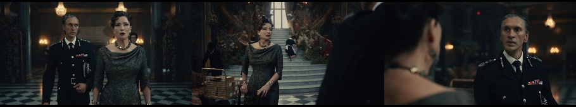
Datum 79
Officer : Well, someone tipped them off and gave them the wrong tip.
Baroness : Thank you for your time. Incompetent as always.
Figure 4.30: Scene Taken from 01:37:53,040 --> 01:38:06,553
Description of the scene:
Baroness commands the police officer to look for Cruella's whereabouts. She wants to make sure if Cruella still alive or dead. Unfortunately the police could not find any trace of Cruella. Baroness looks upset. She even throws a chair to her servant's feet.
Analysis:
Based on the datum above, the utterance is categorized into expressive act because Baroness gives feedback as an expression of disappointment to the officer by judging him incompetent. Baroness performs the act of criticizing.
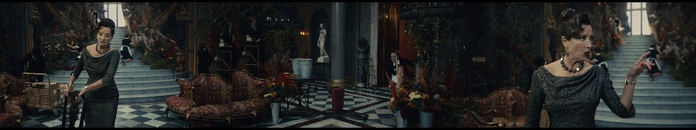
Datum 80
The Servant : (EXCLAIMS)
Baroness : You’re in the way.
Figure 4.31: Scene Taken from 01:38:22,528 --> 01:38:26,532
Description of the scene:
Baroness commands the police officer to look for Cruella's whereabouts. She wants to make sure if Cruella still alive or dead. Unfortunately the police could not find any trace of Cruella. Baroness looks upset. She even throws a chair to her servant's feet. The innocent servant can only remain silent.
Analysis:
Based on the datum above, the utterance is categorized into expressive act because Baroness expresses her wrath and disappointment by throwing a chair to the innocent servant and then blames the servant for blocking her way. Baroness performs the act of blaming.

Discussion: Speech Acts in Each Impoliteness Strategy
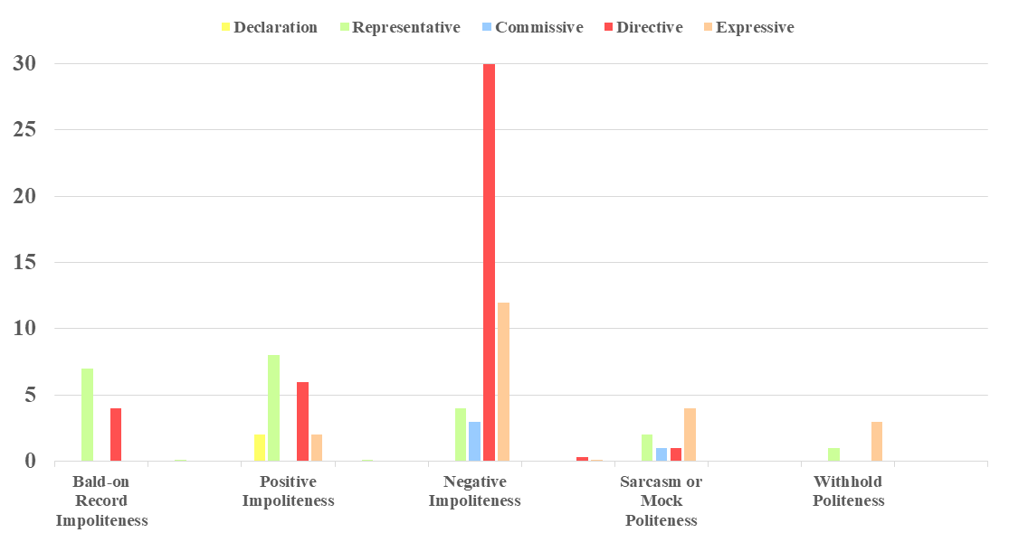
Speech acts in each impoliteness strategy is the number of speech act performed in an impoliteness strategy. The researcher found 16 combination of speech acts in impoliteness strategy shown in this research. They are declaration acts in positive impoliteness strategy with 2 data or 2,22%, representative acts in bald-on record impoliteness with 7 data or 7,78%, representative acts in positive impoliteness strategy with 8 data or 8,89%, representative acts in negative impoliteness strategy with 4 data or 4,44%, representative acts in sarcasm or mock politeness strategy with 2 data or 2,22%, representative act in withhold politeness strategy with 1 datum or 1,11%, commissive acts in negative impoliteness strategy with 3 data or 3,33%, commissive act in sarcasm or mock politeness strategy with 1 datum or 1,11%, directive acts in bald-on record impoliteness strategy with 4 data or 4,44%, directive acts in positive impoliteness strategy with 6 data or 6,67%, directive acts in negative impoliteness strategy with 30 data or 33,33%, directive act in sarcasm or mock politeness strategy with 1 datum or 1,11%, expressive acts in positive impoliteness strategy with 2 data or 2,22%, expressive acts in negative impoliteness strategy with 12 data or 13,33%, expressive in sarcasm or mock politeness with 4 data or 4,44%, and expressive acts in withhold politeness strategy with 3 data or 3,33%. To make it easier to understand in describing the data by category, the following is a figure of speech acts in each impoliteness strategy performed by the main antagonist character in Cruella movie as follows:
Figure 4.32 Speech Acts Found in each Impoliteness Strategy
The figure shows that directive in negative impoliteness gets the highest result which means it is the most frequent speech act in impoliteness strategy performed by the main antagonist character in her utterances. In the discussion below, it will be explained in detail about the analysis of speech acts in each impoliteness strategy performed by the antagonist character in Cruella movie.

Declaration in Positive Impoliteness
Declaration in positive impoliteness means the number of declaration act performed in a positive impoliteness strategy. The researcher found 2 data of this combination in the utterances of main antagonist in Cruella movie. They are on datum 9 and 60. The researcher took one datum of this combination to be presented in this research. The example is as follows:
Datum 60

Roger : You do?
Baroness : So I have a gap to fire you. There’s a gap. You’re fired.
Figure 4.33: Scene Taken from 01:12:04,575 --> 01:12:10,956
Description of the scene:
Roger's opinion does not match Baroness’ wishes so he is fired and kicked out of the car in the middle of the road by Baroness.
Analysis:
Based on the datum above, the utterance is categorized into declaration act in positive impoliteness strategy because Baroness attacks Roger's positive face by firing him. Declaration act is performed when Baroness changes Roger's status so that Roger is no longer her lawyer. Positive impoliteness strategy is applied when Baroness disowns Roger’s desire to contribute as lawyer.

Representative in Bald-on Record Impoliteness
Representative in bald-on record impoliteness means the number of representative act performed in a bald-on record impoliteness strategy. The researcher found 7 data of this combination in the utterances of main antagonist in Cruella movie. They are on datum 1, 15, 16, 17, 18, 19, and 50. The researcher took one datum of this combination to be presented in this research. The example is as follows:
Datum 15

Baroness : My feedback. You’re short, you’re fat, you smell like an anchovy, you’re color-blind, but you pretend you aren’t.
Figure 4.34: Scene Taken from 00:36:16,134 --> 00:36:27,104
Description of the scene:
Men from departments store that stock Baroness’ product come to meet Baroness. They intend to give input to Baroness. Unfortunately, it turns backfired to them. Baroness straightforwardly humiliate them by telling the depravity of their work and how they can be incompetent in it.
Analysis:
Based on the datum above, the utterance is categorized into representative act in bald-on record impoliteness strategy because Baroness bluntly attacks the guy from department store by describing his lack of physical condition. Representative act is performed when Baroness describes the physical condition of the interlocutor based on her observation. Bald-on record impoliteness strategy is applied when Baroness delivers her abusive statements clearly and straightforwardly.

Representative in Positive Impoliteness
Representative in positive impoliteness means the number of representative act performed in a positive impoliteness strategy. The researcher found 8 data of this combination in the utterances of main antagonist in Cruella movie. They are on datum 24, 31, 39, 46, 58, 65, 69, and 71. The researcher took one datum of this combination to be presented in this research. The example is as follows:
Datum 31

Estella : Who was the woman?
Baroness : Not really the point of the story. The story’s about how lucky I am, but anyway, she had a kid.
Figure 4.35: Scene Taken from 00:41:19,438 --> 00:41:28,071
Description of the scene:
Estella notices Baroness’ necklace was worn by Catherine before but Estella pretends not to know it. Estella tries to get information from Baroness to tell about it. Baroness says her necklace was stolen by a woman. Estella is getting more curious about the story of the necklace.
Analysis:
Based on the datum above, the utterance is categorized into representative act in positive impoliteness strategy because Baroness attacks Estella's positive face by ignoring and disinterested to Estella's question but instead focuses on explaining the story about herself. Representative act is performed when Baroness responds to Estella’s question by telling about her as the main topic of the story. Positive impoliteness strategy is applied when Baroness deliberately does not answer Estella's question as she wanted but diverts the conversation by telling her about how important Baroness in her story.

Representative in Negative Impoliteness
Representative in negative impoliteness means the number of representative act performed in a negative impoliteness strategy. The researcher found 4 data of this combination in the utterances of main antagonist in Cruella movie. They are on datum 4, 44, 57, and 78. The researcher took one datum of this combination to be presented in this research. The example is as follows:
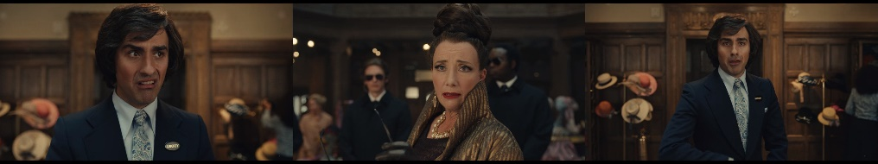
Datum 4

Baroness : You’re a fool.
Figure 4.36: Scene Taken from 00:30:01,844 --> 00:30:03,011
Description of the scene:
Baroness talks to Gerald about Estella who made the artistic window display. Gerald tells that Estella is going to be fired because of the mess she created but apparently Gerald misunderstands about the situation. Gerald does not know that the Baroness actually wants to appreciate the window.
Analysis:
Based on the datum above, the utterance is categorized into representative act in negative impoliteness strategy because Baroness attacks Gerald's negative face by scorning his authority in deciding. Representative act is performed when Baroness tells her opinion about Gerald that she thinks Gerald would waste Estella’s potency. Negative impoliteness strategy is applied when Baroness scorns Gerald's personal decision to fire Estella.

Representative in Sarcasm or Mock Politeness
Representative in sarcasm or mock politeness means the number of representative act performed in a sarcasm or mock politeness strategy. The researcher found 2 data of this combination in the utterances of main antagonist in Cruella movie. They are on datum 5 and 22. The researcher took one datum of this combination to be presented in this research. The example is as follows:
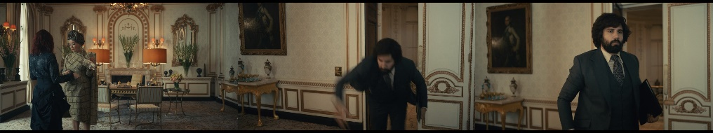
Datum 22

Baroness : Oh. Finally, someone competent.
Roger : Whoa!
Baroness : And someone not.
Figure 4.37: Scene Taken from 00:37:16,570 --> 00:37:23,702
Description of the scene:
Estella seems to have succeeded bringing the lunch as Baroness wanted. Roger suddenly comes stumbling. Baroness gives her opinion about both of them.
Analysis:
Based on the datum above, the utterance is categorized into representative act in sarcasm or mock politeness strategy because Baroness indirectly states that Roger is clumsy and incompetent. Representative act performed when Baroness conveys her thought about Roger being incompetent. Sarcasm or mock politeness strategy is applied when Baroness praises Estella but also mocks Roger indirectly at the same time.

Representative in Withhold Politeness
Representative in withhold impoliteness means the number of representative act performed in a withhold politeness strategy. The researcher found 1 datum of this combination in the utterances of main antagonist in Cruella movie. It is on datum 77. The researcher took this datum to be presented in this research. The example is as follows:
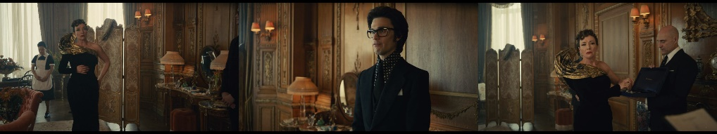
Datum 28

Baroness : All right, how do I look?
Jeffrey : Fabulous.
Baroness : Well, I know that.
Figure 4.38: Scene Taken from 00:38:56,837 --> 00:39:01,925
Description of the scene:
Baroness has finished changing and asks Jeffrey what he thinks of her appearance.
Analysis:
Based on the datum above, the utterance is categorized into representative act in withhold politeness strategy because Baroness does not respond to Jeffrey’s compliment politely as it should be but she conveys it in impolite way instead. Representative act performed when Baroness indirectly says that she agrees with Jeffrey’s statement about her. Withhold politeness strategy is applied when Baroness does not intend to convey her gratitude directly but she shows her arrogance statement instead.

Commissive in Negative Impoliteness
Commissive in negative impoliteness means the number of representative act performed in a negative impoliteness strategy. The researcher found 3 data of this combination in the utterances of main antagonist in Cruella movie. They are on datum 63, 75, and 90. The researcher took one datum of this combination to be presented in this research. The example is as follows:
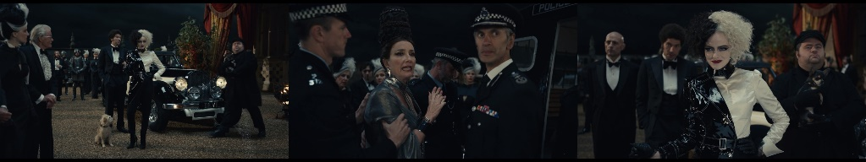
Datum 90

Baroness : She’s really Estella.
Cruella : Cruella de Vil.
Horace : It’s spelled “Devil,” but it’s pronounced “de Vil.”
Baroness : You wait, I’ll get even.
Figure 4.39: Scene Taken from 02:01:08,519 --> 02:01:19,738
Description of the scene:
After pushing Estella into the sea became known to the all witnesses, Baroness is arrested by the authorities. Estella, who has changed her character to Cruella, comes to Baroness’ residence to see her triumph. Baroness irritably explains to the people that the whole thing was Estella’s trick. Cruella smiles proudly for defeating Baroness.
Analysis:
Based on the datum above, the utterance is categorized into commissive act in negative impoliteness strategy because Baroness tries to attack Cruella's negative face by committing to threaten and get revenge. Commissive act is performed when Baroness tells Cruella that she commits to get revenge one day. Negative impoliteness strategy is applied when Baroness frightens Cruella with threats.

Commissive in Sarcasm or Mock Politeness
Commissive in sarcasm or mock politeness means the number of commissive act performed in a sarcasm or mock politeness strategy. The researcher found 1 datum of this combination in the utterances of main antagonist in Cruella movie. It is on datum 77. The researcher took this datum to be presented in this research. The example is as follows:
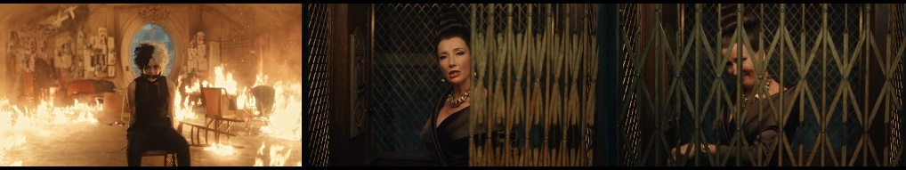
Datum 77

Baroness : I’ll tip off the press. I’d love them to know that you went out in a blaze of glory. (CHUCKLING)
Figure 4.40: Scene Taken from 01:29:21,862 --> 01:29:28,952
Description of the scene:
Cruella arrives home after ruining Baroness’ fashion show. She is surprised with Baroness and her men’ presence. Cruella also does not expect when finding out Horace and Jasper tied up. Cruella is subdued and tied with them. Baroness intends to report them to the police for the crimes they committed. Baroness sprinkled kerosene all over the room and set the building and Cruella on fire. Cruella is helpless in the flame that is keep spreading.
Analysis:
Based on the datum above, the utterance is categorized into commissive act in sarcasm or mock politeness strategy because Baroness commits to make sure Cruella gives up and abandons all her achievements on fire. Commissive act performed when Baroness plans to burn Cruella and promises the press to announce her death caused by fire. Sarcasm or mock politeness strategy is applied when Baroness talks to Cruella about the blaze of glory which it actually means Cruella will lose her glory on fire but Baroness will obtain the glory for defeating Cruella.

Directive in Bald-on Record Impoliteness
Directive in bald-on record impoliteness means the number of directive act performed in a bald-on record impoliteness strategy. The researcher found 4 data of this combination in the utterances of main antagonist in Cruella movie. They are on datum 35, 38, 43, and 51. The researcher took one datum of this combination to be presented in this research. The example is as follows:
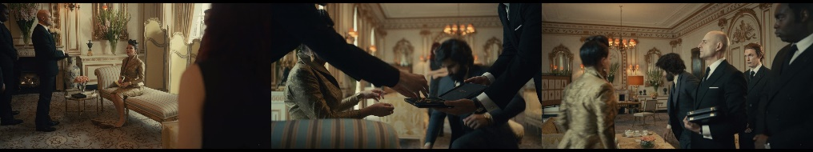
Datum 35

Baroness : Don’t touch the ankle.
Roger : Yes, sorry. It’s in.
Figure 4.41: Scene Taken from 00:42:22,125 --> 00:42:24,920
Description of the scene:
Roger put shoes on Baroness, but Baroness does not seem to like it when Roger touches her ankle.
Analysis:
Based on the datum above, the utterance is categorized into directive act in bald-on record impoliteness strategy because Baroness directly forbids Roger not to touch her ankle. Directive act is performed when Baroness strictly forbids Roger from touching her ankle. Bald-on record impoliteness strategy is applied when Baroness tells her prohibition to Roger clearly and directly which makes Roger feels reprimanded.

Directive in Positive Impoliteness
Directive in positive impoliteness means the number of directive act performed in a positive impoliteness strategy. The researcher found 6 data of this combination in the utterances of main antagonist in Cruella movie. They are on datum 2, 11, 12, 13, 54, and 70. The researcher took one datum of this combination to be presented in this research. The example is as follows:

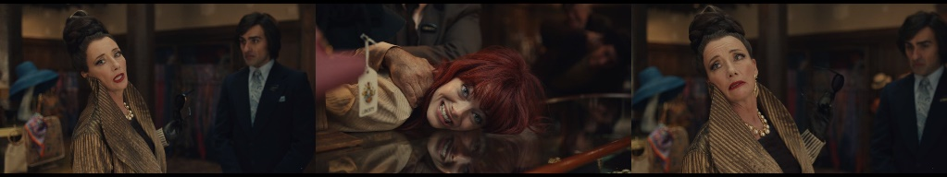
Datum 2

Baroness : You. Grubby girl.
Estella : Yes?
Figure 4.42: Scene Taken from 00:29:41,990 --> 00:29:45,452
Description of the scene:
Baroness calls Estella because Baroness curious with the creator who made the artistic window display at the Liberty.
Analysis:
Based on the datum above, the utterance is categorized into directive act in positive impoliteness strategy because Baroness attacks Estella's positive face by calling her the other names using derogatory nominations. Directive act is performed when Baroness calls Estella to make her respond to Baroness. Positive impoliteness strategy is applied when Baroness does not recognize Cruella’s proper name but she uses derogatory name to call her instead.

Directive in Negative Impoliteness
Directive in negative impoliteness means the number of directive act performed in a negative impoliteness strategy. The researcher found 30 data of this combination in the utterances of main antagonist in Cruella movie. They are on datum 3, 6, 14, 21, 23, 25, 26, 27, 29, 30, 32, 34, 36, 41, 42, 48, 49, 52, 53, 55, 59, 66, 67, 68, 73, 74, 76, 81, 85, and 89. The researcher took one datum of this combination to be presented in this research. The example is as follows:
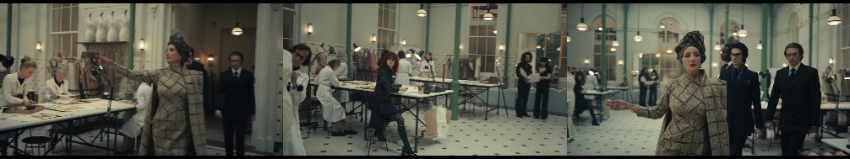
Datum 14

Baroness : Get me lunch. Soy salmon, lemon-zest risotto, cucumber sliced into two-inch diagonals at an eighth of an inch width sprinkled with seven leaves of parsley, shredded, not torn.
Estella : Right.
Figure 4.43: Scene Taken from 00:35:51,318 --> 00:36:02,538
Description of the scene:
Baroness tells Estella to prepare lunch for her. Baroness demands a super complicated lunch menu.
Analysis:
Based on the datum above, the utterance is categorized into directive act in negative impoliteness strategy because Baroness attacks Estella's negative face by putting Estella in a position where she as Baroness’ worker has to obey Baroness’ orders to get her lunch. Directive act is performed when Baroness gives Estella an order to get her lunch. Negative impoliteness strategy is applied when Baroness gives Estella the burden of responsibility to serve her lunch.

Directive in Sarcasm or Mock Politeness
Directive in sarcasm or mock politeness means the number of directive act performed in a sarcasm or mock politeness strategy. The researcher found 1 datum of this combination in the utterances of main antagonist in Cruella movie. It is on datum 72. The researcher took this datum to be presented in this research. The example is as follows:
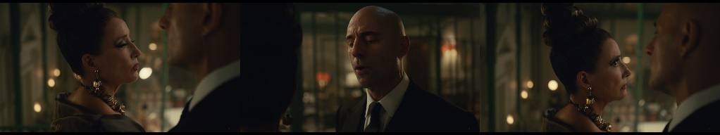
Datum 72
Baroness : Do I pay you for your opinions or for your obedience?
John : Well, are you asking my opinion? I’ll see it’s done.
Figure 4.44: Scene Taken from 01:21:34,144 --> 01:21:42,444
Description of the scene:
Baroness tells John to keep Estella in her office when she arrives. Baroness suspects Estella but John convinces her that Estella is not Cruella.
Analysis:
Based on the datum above, the utterance is categorized into directive act in sarcasm or mock politeness strategy because Baroness asks John about his unwanted opinion that has a tendency to disobey her orders. Directive act performed when Baroness asks a question to John to make him answer why he doubts Baroness’ orders and tell his unwanted opinion to Baroness. Sarcasm or mock politeness strategy is applied when Baroness shows her power by doubting and asking John about his obligation.

Expressive in Positive Impoliteness
Expressive in positive impoliteness means the number of expressive act performed in a positive impoliteness strategy. The researcher found 2 data of this combination in the utterances of main antagonist in Cruella movie. They are on datum 33 and 84. The researcher took one datum of this combination to be presented in this research. The example is as follows:
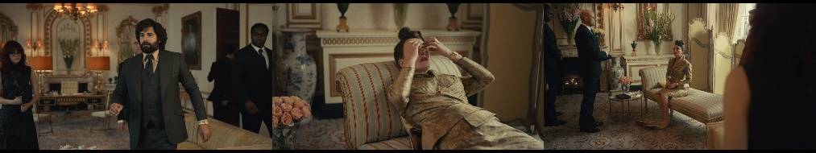
Datum 33

Roger : Baroness, we have that meeting at the Ritz.
Baroness : Oh, for heaven’s sakes. (SIGHS)
Figure 4.45: Scene Taken from 00:42:08,654 --> 00:42:12,449
Description of the scene:
Roger interrupts Baroness' nap to let her know she has a meeting. Baroness feels annoyed so she throws slices of cucumber at Roger which she used to cover her eyes.
Analysis:
Based on the datum above, the utterance is categorized into expressive act in positive impoliteness strategy because Baroness attacks Roger’s positive face by expressing her tiredness with swear words to respond Roger’s invitation. Expressive act is performed when Baroness sighs to express her tiredness. Positive impoliteness strategy is applied when Baroness curses or uses swear words to convey her expression.

Expressive in Negative Impoliteness
Expressive in negative impoliteness means the number of expressive act performed in a negative impoliteness strategy. The researcher found 12 data of this combination in the utterances of main antagonist in Cruella movie. They are on datum 7, 8, 10, 20, 56, 61, 62, 79, 80, 83, 86, and 88. The researcher took one datum of this combination to be presented in this research. The example is as follows:
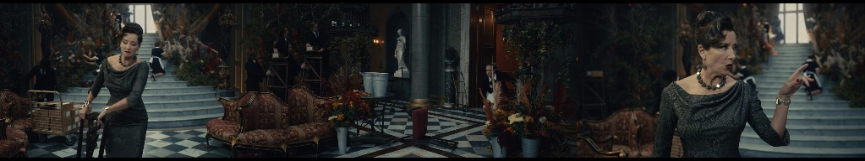
Datum 80

The Servant : (EXCLAIMS).
Baroness : You’re in the way.
Figure 4.46: Scene Taken from 01:38:22,528 --> 01:38:26,532
Description of the scene:
After the fire incident, the police managed to imprison Horace and Jasper. Baroness orders the police to look for Cruella's whereabouts. She wants to make sure if Cruella still alive or dead. Unfortunately the police couldn't find any trace of Cruella. Baroness looks upset. She throws a chair at his servant's feet.
Analysis:
Based on the datum above, the utterance is categorized into expressive act in negative impoliteness strategy because Baroness attacks her servant’s negative face by blaming the maid for blocking her way and not giving the servant's right to self-defense. Expressive act is performed when Baroness expresses her anger by blaming her servant for things that the servant did not actually do to her. Negative impoliteness strategy is applied when Baroness performs abuse of power to take away the maid's personal right to defend herself for what she did not do.

Expressive in Sarcasm or Mock Politeness
Expressive in sarcasm or mock politeness means the number of expressive act performed in a sarcasm or mock politeness strategy. The researcher found 4 data of this combination in the utterances of main antagonist in Cruella movie. They are on datum 37, 45, 82, and 87. The researcher took one datum of this combination to be presented in this research. The example is as follows:
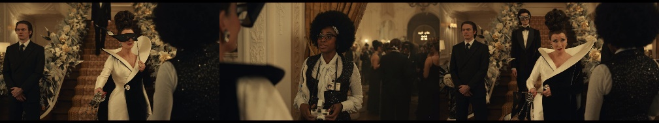
Datum 37

Anita : I’m so grateful you’ve given Tattletale an exclusive tonight.
Baroness : Not apparently grateful enough to observe the dress code.
Figure 4.47: Scene Taken from 00:48:38,544 --> 00:48:45,717
Description of the scene:
Baroness meets Anita in the party. Anita is working as a journalist of Tattletale Press to cover the event. Baroness does not like it when Anita wears wrong dress code.
Analysis:
Based on the datum above, the utterance is categorized into expressive act in sarcasm or mock politeness strategy because Baroness expresses her displeasure by insinuating Anita's dress code and accusing her of being ungrateful. Expressive act performed when Baroness expressive her displeasure to Anita because she wears wrong dress code. Sarcasm or mock politeness strategy is applied when Baroness insinuates Anita for her contradictive behavior.

Expressive in Withhold Politeness
Expressive in withhold politeness means the number of expressive act performed in a withhold politeness strategy. The researcher found 3 data of this combination in the utterances of main antagonist in Cruella movie. They are on datum 40, 47, and 64. The researcher took one datum of this combination to be presented in this research. The example is as follows:
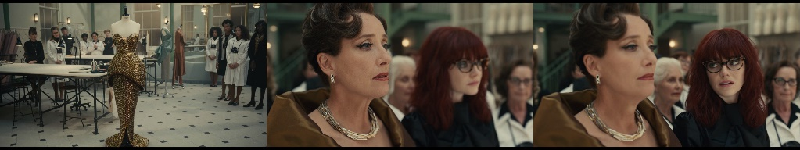
Datum 64

Baroness : It’s…
Estella : Stunning.
Baroness : Hmm.
Figure 4.48: Scene Taken from 01:14:38,145 --> 01:14:44,693
Description of the scene:
Estella was doing her job all night. She sewed the dress using gold trim. The next day Baroness is impressed looking the elegant dress.
Analysis:
Based on the datum above, the utterance is categorized into expressive act in withhold politeness strategy because Baroness tries to hold her amazed expression by not finishing her words. Expressive act performed when Baroness feels impressed looking on the dress. Withhold politeness strategy is applied when Baroness holds her expression when she wants to appreciate the dress.

CHAPTER 5

CONCLUSION AND SUGGESTION

Conclusion
The result shows that there are 90 data found in this research that fulfilled five impoliteness strategies and five classification of speech acts in the utterances of main antagonist character in Cruella movie. The impoliteness strategies found in this research are bald-on record impoliteness with 11 data or 12,22%, positive impoliteness with 18 data or 20%, negative impoliteness with 49 data or 54,44%, sarcasm or mock politeness with 8 data or 8,89%, and withhold politeness with 4 data or 4,44%. It can be concluded that negative impoliteness is the most frequent impoliteness strategy applied by the main antagonist character in Cruella movie because the main antagonist character often deliberately attacks the negative face of her interlocutors.
The classification of speech acts found in this research are declaration with 2 data 2,22%, representative with 22 data or 24,44%, commissive with 4 data or 4,44%, directive with 41 data or 45,56%, and expressive with 21 data 23,33%. It can be concluded that directive act is the most frequent speech act performed by the main antagonist character in Cruella movie because the main antagonist character frequently makes her interlocutors obey her orders.
The researcher found 16 combination of speech acts in impoliteness strategy shown in this research. They are declaration acts in positive impoliteness strategy with 2 data or 2,22%, representative acts in bald-on record impoliteness strategy with 7 data or 7,78%, representative acts in positive impoliteness strategy with 8 data or 8,89%, representative acts in negative impoliteness strategy with 4 data or 4,44%, representative acts in sarcasm or mock politeness strategy with 2 data or 2,22%, representative act in withhold politeness strategy with 1 datum or 1,11%, commissive acts in negative impoliteness strategy with 3 data or 3,33%, commissive act in sarcasm or mock politeness strategy with 1 datum or 1,11%, directive acts in bald-on record impoliteness strategy with 4 data or 4,44%, directive acts in positive impoliteness strategy with 6 data or 6,67%, directive acts in negative impoliteness strategy with 30 data or 33,33%, directive act in sarcasm or mock politeness strategy with 1 datum or 1,11%, expressive acts in positive impoliteness strategy with 2 data or 2,22%, expressive acts in negative impoliteness strategy with 12 data or 13,33%, expressive in sarcasm or mock politeness with 4 data or 4,44%, and expressive acts in withhold politeness strategy with 3 data or 3,33%.
Based on the result of this research, directive speech act in negative impoliteness strategy is the most frequent utterances performed by the main antagonist character in Cruella movie. It can be concluded that the main antagonist character frequently uses negative impoliteness strategy in directive speech act in her utterances because most of utterances spoken by the main antagonist character are imperative sentences. She is described as a chief of a couture house, therefore in addition to having the right to rule over her subordinates and her employees, she also maintains her reputation as a fashion legend who has high status and has the power to dominate. Thus, her utterances commonly are commanding.

Suggestion
After conducting this research, the researcher considers giving suggestions to other researchers. The researcher suggests impoliteness as a topic of discussion for further analysis because this topic is one that is still rarely investigated in pragmatics research. The researcher recommends other researchers to conduct impoliteness and speech acts research on other potential sources to find impoliteness and speech acts phenomena such as in podcast, news interview, etc. The researcher also suggests to other researchers to investigate other variables in researching the impoliteness strategies to obtain the complexity of the research such as analyzing more about the character that perform speech acts in each impoliteness strategy using other theory or other related pragmatics studies.

REFERENCES
Alek. (2018). Linguistik Umum. Jakarta: Penerbit Erlangga.
Brown, P., & Levinson, S. C. (1987). Politeness, Some Universals in Language Usage. Cambridge: Cambridge University Press.
Chaer, A. (2012). Linguistik Umum. Jakarta: Rineka Cipta.
Culpeper, J. (1996). Toward an Anatomy of Impoliteness. Journal of Pragmatics 25, 349-367.
Culpeper, J. (2011). Impoliteness: Using Language to Cause Offence. New York: Cambridge University Press.
Cummings, L. (2019). Pragmatik Sebuah Perspektif Multidisipliner. Yogyakarta: Pustaka Pelajar.
Damadika, S. A. (2021). Illocutionary Acts on Margaret Tates Utterances in the Proposal Movie. Jakarta: Gunadarma University.
Gillespie, C. (Director). (2021). Cruella [Motion Picture].
Grice, P. H. (1975). "Logic and Conversation", Syntax and Semantic 3: Speech Act. New York: Academic Press.
Gunawan, S. (2017). Sherlock Holmes' Impoliteness Strategies and Other Characters' Responses in Sherlock TV Series Season 1 Episode 1. Yogyakarta: Sanata Dharma University.
Hasibuan, A. (2015). Perbedaan Teori Linguistik Ferdinand de Saussure dan Noam Chomsky. Volume III Nomor 2 Juli-Desember 2015.
Hastuti, E., Utami, H. A., & Oswari, T. (2021). Illocutionary Acts Uttered by the Main Character in Fear of Rain Movie: Pragmatic Approach. Journal BASIS Vol.8 No.2 October, 152-164.
Haucsa, G. M., Marzuki, A. G., Alek, & Hidayat, D. N. (2020). Illocutionary Speech Acts Analysis in Tom Cruise's Interview. Academic Journal PERSPECTIVE: Language, Education and Literature Vol 8 (1) May, 11-19.
Kridalaksana, H. (1982). Kamus Linguistik. Jakarta: PT Gramedia.
Krisdayanti, A. (2020). Impoliteness Strategies in Straight Outta Compton Movie. Surakarta: Muhammadiyah University.
Lakoff, R. T. (1989). The limits of politeness: Therapeutic and courtroom discourse. Multilingua 8 (2-3), 101-129.
Leech, G. (1983). Principles of Pragmatics. New York: Longman.
Leech, G. (2021). Prinsip-prinsip Pragmatik. Jakarta: Penerbit Universitas Indonesia.
Markoem, M. (2017). Semantik dan Pragmatik. Tangerang: Pusataka Mandiri.
Meyer, C. F. (2009). Introducing English Linguistics. New York: Cambridge University Press.
Parera, J. D. (2004). Teori Semantik. Jakarta: Penerbit Erlangga.
Pribady, H. (2018). Pengantar Metodologi Penelitian Linguistik. Benedictus. Pontianak: Universitas Tanjung Pura.
Rahardi, K., Setyaningsih, Y., & Dewi, R. P. (2018). Pragmatik Fenomena Ketidaksantunan Berbahasa. Jakarta: Penerbit Erlangga.
Rahardi, R. K. (2019). Pragmatik Konteks Intralinguistik dan Konteks Ekstralinguistik. Yogyakarta: Amara Books.
Rosyadi, I. (2020). Expressive Speech Act in Coco's Movie by Darla K Anderson. Jambi: State Islamic University Thaha Saifuddin.
Sani, F. R., & Suhandoko. (2020). Power and impoliteness in Hancock action movie. Englisia: Journal of Language, Education, and Humanities November 2020 Vol.8 No.1, 25-43.
Searle, J. R. (1979). Expression and Meaning: Studies in the Theory of Speech Acts. New York: Cambridge University Press.
Siahaan, I. P. (2019). Impoliteness Strategies of Lady Gaga in Her Instagram Comments. Medan: University of Sumatera Utara.
Subroto, D. E. (1992). Pengantar Metoda Penelitian Linguistik Struktural. Surakarta: Sebelas Maret University Press.
Sudaryanto. (1998). Metode Linguistik: ke Arah Memahami Metode Linguistik. Yogyakarta: Gadjah Mada University Press.
Sudaryat, Y. (2011). Makna dalam Wacana. Bandung: Yrama Widya.
Suhartono. (2020). Pragmatik Konteks Indonesia. Gresik: Graniti.
Susanto, F. R. (2018). The Study of Impoliteness in the Prison Break Series. Yogyakarta: Sanata Dharma University.
Sutopo, H. B. (2006). Penelitian Kualitatif: Dasar Teori dan Terapannya dalam Penelitian. Surakarta: Sebelas Maret University Press.
Tarigan, H. G. (2015). Pengajaran Pragmatik. Bandung: Penerbit Angkasa.
Utami, K. L. (2019). Strategi Ketidaksantunan Negatif dalam Reality Show 86 di NET TV. Nuansa Indonesia, April 2019 Vol. 21 No. 1, 60-77.
Wijana, I. P., & Rohmadi, M. (2008). Analisis Wacana Pragmatik. Yogyakarta: Media Perkasa.
Yule, G. (2018). Pragmatik. Yogyakarta: Pustaka Belajar.

APPENDICES
No. | Duration | Dialogue | Description of the Scene | Impoliteness Strategies | Speech Acts
 | 00:29:34,274 --> 00:29:40,155 | Gerald: (CLICKS TONGUE) Sorry. I’m not convinced I know…  Baroness: You’re sweating, and I can smell you.  Gerald: Brilliant. Thank you. | Gerald is explaining to Baroness about the incident in the Liberty. Gerald is talking too close on Baroness’ face. Baroness feels uncomfortable. | Bald-on Record Impoliteness | Representative
 | 00:29:41,990 --> 00:29:45,452 | Baroness: You. Grubby girl.  Estella: Yes? | Baroness calls Estella because Baroness curious with the creator who made the artistic window display at the Liberty. | Positive Impoliteness | Directive
 | 00:29:45,536 --> 00:29:46,662 | Baroness: Jeffrey, card. | Baroness orders Jeffrey to give Estella a name card. Estella is recruited to work with her. | Negative Impoliteness | Directive
 | 00:30:01,844 --> 00:30:03,011 | Baroness: You’re a fool. | Baroness talks to Gerald about Estella who made the artistic window display. | Negative Impoliteness | Representative
 | 00:30:03,178 --> 00:30:08,517 | Baroness: That girl put together a better window display than I’ve seen here for 10 years.  Gerald: Hear, hear! | Baroness says that Gerald wasted Estella because she has great talents by making the window display in the Liberty looks better. | Sarcasm or Mock Politeness | Representative
 | 00:33:12,075 --> 00:33:15,704 | Baroness: Oh, that’s enough. New show. We must be perfect. Now go. | Baroness reads a newspaper in front of her employees to inform the achievement of Baroness Design. | Negative Impoliteness | Directive
 | 00:33:48,487 --> 00:33:49,655 | Baroness: It’s foolish. | Baroness’ designers are lining up with their dress design displayed in mannequin. The situation is getting very intense. Baroness approaches one by one to assess the best design to be selected. All designers cannot fulfill Baroness’ criteria. They get bad ratings from Baroness. | Negative Impoliteness | Expressive
 | 00:33:50,656 --> 00:33:51,865 | Baroness: Unhinged. |  | Negative Impoliteness | Expressive
 | 00:33:53,825 --> 00:33:55,410 | Baroness: Well, you’re fired. |  | Positive Impoliteness | Declaration
 | 00:33:57,246 --> 00:34:00,082 | Baroness: Pasty, pasty, pasty. |  | Negative Impoliteness | Expressive
 | 00:34:02,876 --> 00:34:10,092 | Baroness: Hmm.  Estella: (GASPS)  Baroness: Why are you speaking?  Estella: I think you nicked me. | Baroness is interested in the dress designed by Estella. She took out her razor blade to modify the dress by cutting several parts. Accidentally, the blade nicks Estella's hand. | Positive Impoliteness | Directive
 | 00:34:11,885 --> 00:34:16,807 | Estella: Just…  Baroness: Fabrics! Can you get me a red like that? | Baroness raises Estella's injured hand and demands her staff to get a red cloth like blood coming out of the wound on Estella’s hand. | Positive Impoliteness | Directive
 | 00:35:49,107 --> 00:35:51,151 | Baroness: Grubby girl. | Baroness tells Estella to prepare lunch for her. Baroness demands a super complicated lunch menu. | Positive Impoliteness | Directive
 | 00:35:51,318 --> 00:36:02,538 | Baroness: Get me lunch.  Soy salmon, lemon-zest risotto, cucumber sliced into two-inch diagonals at an eighth of an inch width sprinkled with seven leaves of parsley, shredded, not torn.  Estella: Right. |  | Negative Impoliteness | Directive
 | 00:36:16,134 --> 00:36:27,104 | Baroness: My feedback.  You’re short, you’re fat, you smell like an anchovy, you’re color-blind, but you pretend you aren’t. | Men from departments store that stock Baroness’ product come to meet Baroness. They intend to give input to Baroness. Unfortunately, it turns backfired to them. Baroness straightforwardly humiliate them by telling the depravity of their work and how they can be incompetent in it. | Bald-on Record Impoliteness | Representative
 | 00:36:28,480 --> 00:36:30,524 | Baroness: You’re a man who can’t take responsibility. |  | Bald-on Record Impoliteness | Representative
 | 0:36:30,691 --> 00:36:35,779 | Baroness: Your revenues are down 15%, your foot traffic by 12 and a half.  Yes, I do my own research. |  | Bald-on Record Impoliteness | Representative
 | 00:36:35,946 --> 00:36:38,156 | Baroness: Your store hasn’t been refurbished since the Blitz. |  | Bald-on Record Impoliteness | Representative
 | 00:36:38,323 --> 00:36:40,826 | Baroness: People don’t know whether to buy a frock or duck and cover. |  | Bald-on Record Impoliteness | Representative
 | 00:37:01,889 --> 00:37:06,268 | Client 1: Good day.  Baroness: Imbeciles. | The men from departments store leave the meeting with a feeling of irritation from being humiliated by Baroness in the face. Apparently they fail to accomplish their duty. | Negative Impoliteness | Expressive
 | 00:37:09,396 --> 00:37:11,315 | Baroness: Lunch, now. | During the meeting, Estella had come to bring Baroness’ lunch. After waiting for the meeting to end, she approaches Baroness with lunch. | Negative Impoliteness | Directive
 | 00:37:16,570 --> 00:37:23,702 | Baroness: Oh. Finally, someone competent.  Roger: Whoa!  Baroness: And someone not. | Estella seems to have succeeded in bringing the lunch as Baroness wanted. Roger comes stumbling. | Sarcasm or Mock Politeness | Representative
 | 00:37:35,464 --> 00:37:38,383 | Baroness: Time for my nine-minute power nap.  Box up my lunch, Estella.  (GRUNTS) | Baroness is going to take a nap. She tells Estella to package the food. | Negative Impoliteness | Directive
 | 00:37:48,685 --> 00:38:00,447 | Baroness: It could do with a lining.  Estella: You could use tulle to puff it out, give it some body.  Baroness: That’s what I just said. | Estella is drawing a design while Baroness is having her lunch. Baroness notices Estella’s design. | Positive Impoliteness | Representative
 | 00:38:14,545 --> 00:38:16,421 | Baroness: Keep up, Estella. | Baroness and her men rush into her workplace. Baroness tells Estella to follow her. | Negative Impoliteness | Directive
 | 00:38:25,347 --> 00:38:26,723 | Baroness: Jewels. | Baroness tells John to get her jewels from the safe. Estella spots the safe’s key. | Negative Impoliteness | Directive
 | 00:38:27,641 --> 00:38:31,061 | Baroness: And, Estella, make the bodice pencil thin. | Baroness who is changing her clothes tells Estella to do something with her design. Estella observes the security of Baroness’ safe. | Negative Impoliteness | Directive
 | 00:38:56,837 --> 00:39:01,925 | Baroness: All right, how do I look?  Jeffrey: Fabulous.  Baroness: Well, I know that. | Baroness has finished changing and orders Jeffrey what he thinks of her appearance. | Withhold Politeness | Representative
 | 00:39:02,009 --> 00:39:03,051 | Baroness: Show me. | Baroness tells Estella to show her drawing. Baroness looks amazed to it. | Negative Impoliteness | Directive
 | 00:40:11,119 --> 00:40:23,674 | Baroness: There’s something about it that irritates me and I always trust my instincts.  Estella: I thought maybe if you tighten the silhouette…  Baroness: Oh, you thought, did you? | Baroness and Estella are in Baroness’ private room. They are discussing about the designs. Baroness seems restless. Estella gives her an advice but Baroness feels offended. | Negative Impoliteness | Directive
 | 00:41:19,438 --> 00:41:28,071 | Estella: Who was the woman?  Baroness: Not really the point of the story.  The story’s about how lucky I am, but anyway, she had a kid. | Estella notices Baroness’ necklace and asks Baroness to tell about it. Estella is getting more curious about the story of the necklace. | Positive Impoliteness | Representative
 | 00:42:06,944 --> 00:42:08,487 | Roger: (CLEARS THROAT)  Baroness: Speak. | Baroness is taking a nap. Suddenly Roger comes to give information to Baroness. Roger has to interrupt her nap by clearing his throat. | Negative Impoliteness | Directive
 | 00:42:08,654 --> 00:42:12,449 | Roger: Baroness, we have that meeting at the Ritz.  Baroness: Oh, for heaven’s sakes.  (SIGHS) | Roger interrupts Baroness' nap to let her know she has a meeting. Baroness feels annoyed so she throws slices of cucumber at Roger which she used to cover her eyes. | Positive Impoliteness | Expressive
 | 00:42:18,288 --> 00:42:20,040 | Baroness: Necklace. Roger, shoes. | Baroness orders Jeffrey to get her necklace and Roger to bring her shoes. She is preparing herself for the meeting. | Negative Impoliteness | Directive
 | 00:42:22,125 --> 00:42:24,920 | Baroness: Don’t touch the ankle.  Roger: Yes, sorry. It’s in. | Roger put shoes on Baroness, but Baroness does not seem to like it when Roger touches her ankle. | Bald-on Record Impoliteness | Directive
 | 00:42:25,087 --> 00:42:26,088 | Baroness: Come along. | Baroness commands her men to follow her out of the room. | Negative Impoliteness | Directive
 | 00:48:38,544 --> 00:48:45,717 | Anita: I’m so grateful you’ve given Tattletale an exclusive tonight.  Baroness: Not apparently grateful enough to observe the dress code. | Baroness meets Anita in the party. Anita is working as a journalist of Tattletale Press to cover the event. Baroness does not like it when Anita wears wrong dress code. | Sarcasm or Mock Politeness | Expressive
 | 00:48:48,554 --> 00:48:50,722 | Baroness: No color. | The party’s dress code is black and white. Baroness does not like Anita’s bag that has blue spot. | Bald-on Record Impoliteness | Directive
 | 00:48:50,889 --> 00:48:59,523 | Anita: Well, my pen must have leaked. It’s tools of my trade.  Baroness: No one is interested in what you write, my dear.  Just in how I look. | Anita explains to Baroness about the blue spot in her bag but it looks like Baroness does not even care. She throws it away. | Positive Impoliteness | Representative
 | 00:49:06,572 --> 00:49:10,951 | John: You look ravishing, Baroness.  Baroness: Master of understatement, as usual. | John tells his opinion about Baroness’ look in the party. | Withhold Politeness | Expressive
 | 00:49:57,956 --> 00:49:59,291 | Baroness: Get her. | Cruella comes into the party in an outfit that catch the public's attention. Baroness looks displeased with her presence and tells the guards to arrest her. | Negative Impoliteness | Directive
 | 00:51:51,737 --> 00:51:53,906 | Baroness: Oh, for heaven’s sake, just bring her to me. | Baroness orders John to bring Cruella because all of the guards are incapable to get her. Cruella has made the party go wild. | Negative Impoliteness | Directive
 | 00:52:09,755 --> 00:52:11,381 | Baroness: Nothing to see here. | Cruella becomes center of attention. Baroness and Cruella are face to face. People at the party are staring to them. | Bald-on Record Impoliteness | Directive
 | 00:54:08,832 --> 00:54:17,883 | Baroness: Let me give you some advice.  If you need to talk about power, you don’t have it.  Cruella: Well, I don’t have it, which is why I need to talk about it, which is why I’m here. | Baroness and Cruella are having a conversation. Baroness asks Cruella’s purpose and where she comes from. Cruella is actually buying time to make the ‘angle’ runs smoothly because Horace and Jasper are dealing with the guards. They are going to steal Baroness’ necklace in that night. | Negative Impoliteness | Representative
 | 00:54:18,050 --> 00:54:24,431 | Cruella: Am I going to have to catch you up a lot, or can you keep up?  Baroness: You’re funny. |  | Sarcasm or Mock Politeness | Expressive
 | 00:54:43,408 --> 00:55:08,517 | Baroness: Where are you from?  Cruella: Oh. Well, um…  Up… north. Well, sort of.  It’s a bit south, really, of north, which is basically west.  Baroness: All right, that’s enough. I’ve loved our little chat, but I’m afraid that now I’m going to have to have you arrested, um, for trespassing. |  | Positive Impoliteness | Representative
 | 01:04:57,022 --> 01:05:13,497 | Baroness: Did you happen to notice her hair?  John: Coincidence.  Apparently all the young people are doing it now.  Baroness: Thank you, John. You’re such an enormous… help.  John: I do my best.  Baroness: Mmm. | Baroness and John discuss about Cruella's presence at last night's party. Baroness identifies Cruella as someone familiar but John denies it. John seems to be covering it up and Baroness still looks suspicious. | Withhold Politeness | Expressive
 | 01:05:22,172 --> 01:05:26,718 | Baroness: Ah. Here she is.  Late. Grab a pad. | Estella came late. The designers are lining up, ready to draw following Baroness’ instructions. Baroness tells to all their designers that she need new authentic designs for her Spring Collection. | Negative Impoliteness | Directive
 | 01:05:59,293 --> 01:06:07,593 | Baroness: I need ten pieces that work by 3:00 a.m.  Go. |  | Negative Impoliteness | Directive
 | 01:06:10,095 --> 01:06:12,723 | Estella: Thank you.  Baroness: Gratitude’s for losers. | All the designers are leaving the room. Estella innocently expresses her gratitude which Baroness does not really need and does not care about it. | Bald-on Record Impoliteness | Representative
 | 01:06:14,057 --> 01:06:18,645 | Estella: Oh. Good advice, thanks.  Baroness: What did I just say?  Estella: Uh, don’t thank you, so… |  | Bald-on Record Impoliteness | Directive
 | 01:06:25,944 --> 01:06:29,156 | Baroness: What do you mean, the dogs have gone?  Well, find them! | Baroness picks up the phone. She receives reports of her dogs being kidnapped. The dogs were kidnapped while at the pet grooming. | Negative Impoliteness | Directive
 | 01:08:06,503 --> 01:08:10,674 | Baroness: Find her. And, Roger, find out everything about her. | Cruella becomes headline on newspapers. Baroness does not look happy about it. She orders Roger to find out Cruella. | Negative Impoliteness | Directive
 | 01:09:25,040 --> 01:09:34,091 | Estella: Can I get you some cucumber? Thinly sliced.  Baroness: Go. | Baroness looks upset because her dogs and necklace are missing. She is also annoyed with Cruella's news. Estella takes the initiative to provide services to her so that Baroness could be more relaxed. | Positive Impoliteness | Directive
 | 01:09:34,258 --> 01:09:40,722 | Baroness: And get your dried-up, desiccated little brain working.  Estella: Of course. And thank you. |  | Negative Impoliteness | Directive
 | 01:10:26,560 --> 01:10:32,691 | Baroness: Oh, Estella, I am surprised at you holding out on me.  Estella: But I was on my lunch break in a public space. | Estella was on her lunch break. She was also designing a dress. Suddenly the pad was taken by Baroness' men. She was also dragged away to be brought before Baroness. Arriving at Baroness room, Estella is surprised by what had happened. Baroness takes her design that Estella made to be displayed on the board as a new model for her spring collection. | Negative Impoliteness | Expressive
 | 01:10:32,858 --> 01:10:43,869 | Baroness: Yes, I own the alley.  Estella: Really? You can own alleys?  Baroness: Alleys, designs, people, their souls.  Check your employment contract. |  | Negative Impoliteness | Representative
 | 01:10:50,375 --> 01:10:55,881 | Baroness: Well, I seem to have found my new signature piece.  How do you like it? |  | Positive Impoliteness | Representative
 | 01:11:49,142 --> 01:12:04,408 | Baroness: We need to sue her, for defamation, false imprisonment, vandalism. Something.  Roger: Well, having been through the statute and talked to the police, I don’t know we have a legal avenue for…  Baroness: I need you to stop talking, Roger. | Cruella's appearance in disrupting Baroness’ event is very troubling for Baroness. She wants Cruella arrested and punished. She is discussing it with her lawyer, Roger in the car. | Negative Impoliteness | Directive
 | 01:12:04,575 --> 01:12:10,956 | Roger: You do?  Baroness: So I have a gap to fire you.  There’s a gap. You’re fired. | Roger's opinion does not match Baroness’ wishes so he is fired and kicked out of the car in the middle of the road by Baroness. | Positive Impoliteness | Declaration
 | 01:12:24,261 --> 01:12:26,847 | Baroness: You’ll need more than eyeliner, you plain little thing. | Baroness and her men come to Tattletale's office. She throws the newspaper on Anita's table while Anita is doing her makeup. | Negative Impoliteness | Expressive
 | 01:12:31,768 --> 01:12:42,696 | Baroness: Who is she? And more importantly, where is she?  Anita: I don’t know.  Baroness: Did you just lie to me? | Anita is shocked with Baroness’ presence. Baroness wants to find out about Cruella through Anita. | Negative Impoliteness | Expressive
 | 01:12:44,531 --> 01:12:56,168 | Anita: I… No, I…  Baroness: Don’t cry.  Anita: (SCOFFS) I’m not.  Baroness: You will.  (BARONESS CHUCKLES) |  | Negative Impoliteness | Commissive
 | 01:14:38,145 --> 01:14:44,693 | Baroness: It’s…  Estella: Stunning.  Baroness: Hmm. | Estella was doing her job all night. She sewed the dress using gold trim. The next day Baroness is impressed looking the elegant dress. | Withhold Politeness | Expressive
 | 01:14:46,862 --> 01:14:51,408 | Baroness: I’ve done it again.  Let’s go make history. |  | Positive Impoliteness | Representative
 | 01:14:52,201 --> 01:14:55,245 | Baroness: I need a drink. Estella, come. | Baroness wants to have a drink in restaurant to celebrate for the new Spring Collection dress. | Negative Impoliteness | Directive
 | 01:15:14,014 --> 01:15:15,432 | Baroness: Give it to me, for heaven’s sake.  (CORK POPS)  (CHUCKLES) | Baroness and Estella are at the fine dining restaurant. The waiter is struggling to open the wine. The impatient Baroness grabs the bottle of wine and opens it herself making the cap of the bottle pops into the waiter’s eye. | Negative Impoliteness | Directive
 | 01:15:18,101 --> 01:15:19,353 | Baroness: Go. |  | Negative Impoliteness | Directive
 | 01:15:27,319 --> 01:15:28,654 | Baroness: Here’s to me.  Estella: (SCOFFS) | Baroness and Estella toast celebrating the new dress. Baroness says they celebrate for her. Estella scoffs by laughing at her. Estella says that she made the signature dress for Baroness so she deserves the praise and celebration. | Positive Impoliteness | Representative
 | 01:15:33,992 --> 01:15:42,292 | Baroness: Who the hell else would I drink to?  Estella: To me? For creating your signature piece? |  | Positive Impoliteness | Directive
 | 01:15:43,001 --> 01:15:51,468 | Baroness: You’re helpful to me, is all.  As soon as you’re not, you’re dust.  Estella: Inspiring talk.  Thank you. |  | Positive Impoliteness | Representative
 | 01:21:34,144 --> 01:21:42,444 | Baroness: Do I pay you for your opinions or for your obedience?  John: Well, are you asking my opinion?  I’ll see it’s done. | Baroness tells John to keep Estella in her office when she arrives. Baroness suspects Estella but John convinces her that Estella is not Cruella. | Sarcasm or Mock Politeness | Directive
 | 01:21:59,294 --> 01:22:00,420 | Baroness: Speak. | Baroness comes down the stairs and meets Jeffrey. Baroness knows that something is not going well when she looks at Jeffrey’s face. | Negative Impoliteness | Directive
 | 01:22:07,553 --> 01:22:13,141 | Jeffrey: There’s something wrong with the lock, Your Ladyship.  Baroness: I don’t care what you have to do, get it open! | The security lock on the safe door containing Baroness’ collection of dresses is broken while the fashion show has been started. Baroness tells Jeffrey to fix the problem no matter what. | Negative Impoliteness | Directive
 | 01:27:11,023 --> 01:27:22,367 | Cruella: This is between us.  Let Jasper and Horace, imbeciles that they are for letting you follow them, let them go.  Baroness: Oh, I shall. They’re going to jail. | Cruella arrives home after ruining Baroness fashion show. She is surprised with Baroness and her men’ presence. Cruella also does not expect when finding out Horace and Jasper tied up. Cruella is subdued and tied with them. Baroness intends to report them to the police for the crimes they committed. Baroness sprinkled kerosene all over the room and set the building and Cruella on fire. Cruella is helpless in the flame that is keep spreading. | Negative Impoliteness | Commissive
 | 01:28:27,140 --> 01:28:36,066 | Estella: I’m gonna kill you. And your dogs.  Baroness: I’m waiting. |  | Negative Impoliteness | Directive
 | 01:29:21,862 --> 01:29:28,952 | Baroness: I’ll tip off the press.  I’d love them to know that you went out in a blaze of glory.  (CHUCKLING) |  | Sarcasm or Mock Politeness | Commissive
 | 01:37:41,987 --> 01:37:47,618 | Police officer: The boys are locked up, but we have a problem.  Baroness: I don’t pay you for problems. | After the fire incident, the police managed to imprison Horace and Jasper. Baroness orders the police to look for Cruella's whereabouts. She wants to make sure if Cruella still alive or dead. Unfortunately the police couldn't find any trace of Cruella. Baroness looks upset. She throws a chair at his servant's feet. | Negative Impoliteness | Representative
 | 01:37:53,040 --> 01:38:06,553 | Police officer: Well, someone tipped them off and gave them the wrong tip.  Baroness: Thank you for your time.  Incompetent as always. |  | Negative Impoliteness | Expressive
 | 01:38:22,528 --> 01:38:26,532 | The maid: (EXCLAIMS)  Baroness: You’re in the way. |  | Negative Impoliteness | Expressive
 | 01:47:50,429 --> 01:47:51,638 | Baroness: Psst! | Baroness is having another party at her residence. Her maids help her get dressed. John comes over to Baroness. Baroness told her maid to leave. Baroness and john discuss about Cruella. Baroness is already know that Cruella is her own daughter. Baroness used to tell John to get rid of her daughter. Baroness. Baroness is disappointed that John didn't complete his task as she wished. | Negative Impoliteness | Directive
 | 01:48:05,819 --> 01:48:16,830 | John: I hardly thought you meant you wanted me to kill your only child.  Baroness: And I thought we knew each other. |  | Sarcasm or Mock Politeness | Expressive
 | 01:49:02,751 --> 01:49:04,628 | Baroness: Oh! Just find her, you idiots! | Baroness instructs her guards to find Cruella. She is sure that Cruella is still alive and will again mess up the party that night. One of the guards shows off a Taser gun to Baroness to use on Cruella, but it turns backfired because Baroness uses it to him. Baroness feels so upset because of her men being incompetent. | Negative Impoliteness | Expressive
 | 01:49:11,677 --> 01:49:17,224 | Baroness: Why am I the only one who’s competent?  John: Must be very tiring. |  | Positive Impoliteness | Expressive
 | 01:54:26,742 --> 01:54:34,249 | Baroness: She’s here. I can feel it.  Find her. | In the crowd, Cruella pokes Baroness with a needle to distract her so that Cruella can steal Baroness’ dog whistle. Baroness does not realize that Cruella have approached her. | Negative Impoliteness | Directive
 | 01:56:38,081 --> 01:56:45,589 | Cruella: I hate to ruin your party, but I’ve come to evict you.  Baroness: (CHUCKLES) Don’t be absurd. | Cruella and Baroness are face to face in the backyard. Cruella purposely lures Baroness out of the party. Baroness fails to attack Cruella with her dogs because Cruella has Baroness’ dog whistle so the dogs are more obedient to Cruella. Cruella reveals her identity to Baroness as her biological child and inherits the Baron's wealth | Negative Impoliteness | Expressive
 | 01:59:11,276 --> 01:59:19,618 | Cruella: You’re not going to push me off the cliff, are you?  Baroness: (WHISPERS) You’re so funny, dear.  So funny. | Baroness pretends to have just found out that Cruella is her biological child. She asks Cruella to come back to her. Baroness takes her daughter for a hug. | Sarcasm or Mock Politeness | Expressive
 | 01:59:36,510 --> 01:59:37,511 | Baroness: Idiot. | When Baroness and Cruella are hugging each other in the backyard at the edge of the cliff, Baroness pushes Cruella down. Cruella falls into the sea. | Negative Impoliteness | Expressive
 | 02:01:03,013 --> 02:01:08,352 | Baroness: Can’t you idiots see?  That Estella person, it’s a trick. | After pushing Estella into the sea became known to the all witnesses, Baroness is arrested by the authorities. Estella, who has changed her character to Cruella, comes to Baroness’ residence to see her triumph. Baroness irritably explains to the people that the whole thing was Estella’s trick. Cruella smiles proudly for defeating Baroness. | Negative Impoliteness | Directive
 | 02:01:08,519 --> 02:01:19,738 | Baroness: She’s really Estella.  Cruella: Cruella de Vil.  Horace: It’s spelled “Devil,” but it’s pronounced “de Vil.”  Baroness: You wait, I’ll get even. |  | Negative Impoliteness | Commissive

